PiXL Gateway: Masterclass - Chemistry
Contents:
Checklist of Skills and Basic Knowledge (page 2)
- Amount of Substance (page 4)
  - Avogadro constant
  - Ideal gas equation
  - Empirical and Molecular formula
  - Percentage yield and atom economy
  - Calculating concentration and uncertainty

- Bonding (page 7)
  - Ionic
  - Covalent
  - Metallic
  - Properties of substances
  - Bond polarity

- Chemical Equilibria (page 10)
  - Simple collision theory
  - Factors affecting rate of reaction
  - Dynamic equilibrium
  - Le Chatelier’s principle
Checklist of skills and basic knowledge
Amount of Substance
I can define relative atomic mass (Ar) and relative molecular mass (Mr)
I can carry out calculations using the Avogadro constant
I can carry out calculations using mass of substance, Mr and amount in moles
I can carry out calculations using concentration, volume and amount of substance in a solution
I can use the ideal gas equation pV = nRT in calculations
I can calculate empirical formula from data giving composition by mass or percentage mass
I can calculate molecular formula from the empirical formula and relative molecular mass
I can calculate percentage yield and atom economy from given data
I can calculate the concentration of a solution from mean titre results
I can calculate the uncertainty in a burette
Bonding
I can describe ionic bonding
I can predict the charge on a simple ion using the position of the element in the periodic table
I can construct formulas for ionic compounds
I can describe the difference between a single covalent bond and a co-ordinate (dative covalent) bond
I can represent a covalent bond using a line and a co-ordinate bond using an arrow
I can describe metallic bonding
I can describe and explain the properties of: diamond, graphite, iodine, magnesium and sodium chloride as examples of one of these 4 crystal structures: ionic, metallic, macromolecular, molecular
I can relate the melting point and conductivity of materials to the type of structure and bonding present
I can draw diagrams to represent structures involving specified numbers of particles
I can define electronegativity
I can use partial charges to show that a bond is polar
Chemical Equilibria
I can define the term activation energy
I can explain why most collisions do not lead to a reaction
I can draw and explain Maxwell-Boltzmann distribution curves for different temperatures
I can define the term: rate of reaction
I can use the Maxwell-Boltzmann distribution curve to explain why a small increase in temperature can lead to a large increase in rate
I can explain how a change in concentration or a change in pressure influences the rate of a reaction (collision frequency)
I can define the term catalyst and explain how they work (activation energy; alternative pathway)
I can use a Maxwell-Boltzmann distribution to help explain how a catalyst increases the rate of a reaction involving a gas
I can explain what is happening in a reversible reaction at equilibrium
I can use Le Chatelier's principle to predict qualitatively the effect of changes in temperature, pressure and concentration on the position of equilibrium
I can explain why, for a reversible reaction used in an industrial process, a compromise temperature and pressure may be used

Presentation 1: Amount of Substance
a. Avogadro Constant
The relative atomic mass (A_{r}) is the weighted average of the masses of its isotopes relative to 1/12 of the mass of a carbon-12 atom. The relative atomic masses can be found in the periodic table.
The relative molecular mass (M_{r}) is the sum of the relative atomic masses of the atoms in the numbers shown in the formula.
In a balanced chemical equation, the sum of the relative formula masses of the reactants equals the sum of the relative formula masses of the products.
For example: 2Mg + O₂ 2MgO
(2x24) + (2x16) 2 x (24+16)
80 80
Chemical amounts are measured in moles. The symbol for the unit mole is mol.
The mass of one mole of a substance in grams is numerically equal to its relative formula mass. One mole of a substance contains the same number of the stated particles, atoms, molecules or ions as one mole of any other substance.
The number of atoms, molecules or ions in a mole of a given substance is the Avogadro constant. The value of the Avogadro constant is 6.02 x 10²³ per mole.
For example, 1 mole of H₂O has a mass of 18g and contains : 6.02 x 10²³ water molecules, 6.02 x 10²³ oxygen atoms and 1.204 x 10²⁴ hydrogen atoms (2 x Avogadro).
For simple calculation questions, you need to be able to recall, use and rearrange the following equation:
Number of moles = mass (g) or mass (g)
A_{r} M_{r}
Going Deeper
Can you calculate the number of magnesium and chloride ions in 50g of magnesium chloride?

b. Ideal Gas Equation
An ideal gas is one in which the molecules are far enough apart so that intermolecular forces can be neglected. At high pressures, such forces cause significant departure from the Ideal Gas Equation, and more complicated equations have been devised to treat such cases.

The Ideal Gas Equation, however, gives useful results for most gases at pressures less than 100 atmospheres.
pV = nRT
where:
p = the pressure in pascals, Pa or newtons per square metre, Nm⁻²
V = the volume in cubic metres, m³ (not cm³)
n = the number of moles
R = the gas constant, 8.31441 JK⁻¹mol⁻¹
T = the temperature in kelvin, K. Add 273 to the temperature in degrees Celsius
Going Deeper
The density of ethane is 1.264 gdm⁻³ at 20 ⁰C and 101325 Pa. Can you calculate the relative formula mass of ethane?

c. Empirical and Molecular Formula
The empirical formula tells you the simplest ratio of the various atoms present in a substance. For example, the empirical formula of ethane (which has a molecular formula of C₂H₆) would be CH_{3.}
The molecular formula gives the total number of atoms of each element present in a molecule of the substance. If the empirical formula and relative molecular mass is known, the molecular formula can be calculated.
For example, the empirical formula of ribose is CH₂O. The molar mass of this compound was determined to be 150g/mol. What is the molecular formula of ribose?
Step 1: Determine the molar mass of the empirical formula 12 + (2 x 1) + 16 = 30gmol⁻¹
Step 2: Divide the given molar mass by your answer from step 1 150gmol⁻¹ / 30gmol⁻¹ = 5
Step 3: Multiply your empirical formula by your answer from step 2 C_{1x5}H_{2x5}O_{1x5} = C₅H₁₀O₅
Going Deeper
A hydrated salt is analysed and has the following percentage composition by mass:
Cr, 19.51%; Cl, 39.96%; H,4.51%; O, 36.02%
Calculate the formula of the compound showing clearly the water of crystallisation.

d. Percentage Yield and Atom Economy
The yield of a reaction is the actual mass of product obtained. The percentage yield can be calculated: %$yield=\frac{actual yield}{theoretical yield}$ x 100
Reactions rarely produce 100% yield. Reasons for this could be the reaction is reversible, or side reactions are occurring or there are errors in experimental procedures.
Atom economy is a measure of the amount of starting materials that end up as useful products. It is important for sustainable development and for economic reasons to use reactions with high atom economy. The percentage atom economy is calculated using the following equation:
Relative formula mass of desired product from equation x 100
Sum of relative formula mass of all reactants from equation
Going Deeper
Ethanol can be produced by fermenting sugar:
C₆H₁₂O₆ 2C₂H₅OH + 2CO₂
Calculate the atom economy for the reaction. Can you suggest a more effective method for ethanol production?

e. Calculating Concentration and Uncertainty
The concentration of a solution is the amount of solute per volume of solution. Chemists measure concentration in moles per cubic decimetre (mol/dm³).
Concentration (mol/dm³) = amount (mol) $÷$ volume (dm³)
If the volumes of two solutions that react completely are known and the concentrations of one solution is known, the concentration of the other solution can be calculated.
Uncertainty is an estimate attached to a measurement which characterises the range of values within which the true value lies e.g. 44.0 $± 0.4$
For a burette:
- Graduated in division every 0.1 cm³
- Maximum error is half a division i.e. $±$ 0.05 cm³
- Burettes are read twice, so the overall maximum error is 2 x 0.05 = $±$0.1 cm³
Going Deeper
A student prepares a solution of sodium sulfate, Na₂SO₄, by adding 6.25 x 10⁻² moldm⁻³ sulfuric acid, H₂SO₄, from a burette to 25.0 cm³ of 0.124moldm⁻³ NaOH in a conical flask.
2NaOH_{(aq)} + H₂SO_{4(aq)} Na₂SO_{4(aq)} + 2H₂O_{(l)}
Calculate the minimum volume of the acid that the student would need to completely react with the NaOH present.

Presentation 2: Bonding
a. Ionic
Ionic bonds form between metals and non-metals. Ionic bonding involves the transfer of electrons in the outer shells.
Metals lose electrons to become positively charged ions.
Non-metals gain electrons to become negatively charged ions.
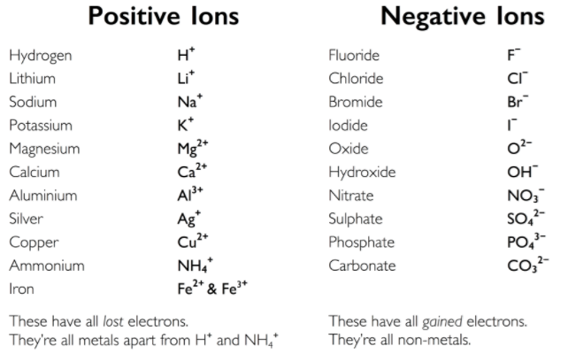
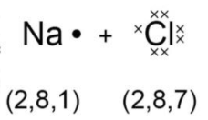
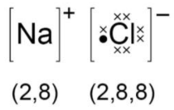
The electrostatic attraction between the oppositely charged ions is called ionic bonding. The electron transfer during the formation of an ionic compound can be represented by a dot and cross diagram:

Going Deeper
Explain why magnesium oxide has a higher melting point than sodium chloride.

b. Covalent
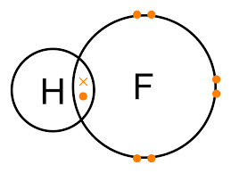
Covalent bonds form between non-metals. Covalent bonding is a shared pair of electrons in the outer shells. Therefore a single bond is one shared pair of electrons, a double bond is two shared pairs of electrons etc.

Covalent bonding happens because the electrons are more stable when attracted to two nuclei than when attracted to only one.
Covalent bonds should not be regarded as shared electron pairs in a fixed position; the electrons are in a state of constant motion and are best regarded more as charge clouds.
A dative covalent bond (or coordinate bond) is a pair of electrons shared between two atoms, one of which provides both electrons to the bond.
A dative covalent bond is represented by a short arrow from the electron providing both electrons to the electron providing neither.
Going Deeper
Name the type of bond formed between N and Al in H₃NAlCl₃ and explain how this bond is formed.

c. Metallic
A metallic bond is an attraction between cations and a sea of electrons.
Metallic bonds are formed when atoms lose electrons and the resulting electrons are attracted to all the resulting cations. Metallic bonding happens because the electrons are attracted to more than one nucleus and hence more stable. The electrons are delocalised – they are not attached to any particular atom, but are free to move between the atoms.
Going Deeper
Explain why aluminium has a higher melting point than sodium.

d. Properties of Substances
Ionic:
- The attraction between opposite ions is very strong. A lot of kinetic energy is required to overcome them and the melting point and boiling point of ionic compounds is very high.
- Since ions are held strongly in place by the other ions, they cannot move or slip over each other easily and are therefore hard and brittle.
- Ionic compounds contain charged ions so they are able to move towards charged electrodes and will therefore conduct electricity. In the solid state the ions are not free to move as they are tightly held in place. They do not conduct electricity. In the liquid state, the ions are free to move and so can move towards their respective electrodes. Ionic compounds can conduct electricity in the liquid state.
Metallic:
- Metallic bonding is relatively strong so the melting and boiling points of metals are relatively high. Smaller ions, and those with a high charge, attract the electrons more strongly and so have higher melting points than larger ions with a low charge.
- Delocalised electrons are free to move throughout the crystal in a certain direction when a potential difference is applied. Metals therefore conduct electricity in the solid state. The delocalised electron system is still present in the liquid state, so metals can also conduct electricity well in the liquid state.
- Metal cations can be moved around and there will still be delocalised electrons available to hold the cations together. The metal cations can therefore slip over each other fairly easily. As a result, metals tend to be soft, malleable and ductile.
Molecular covalent:
- Melting and boiling points are generally low, since intermolecular forces are weak. Intermolecular forces also decrease rapidly with increasing distance, so there is often little difference in the melting and boiling points.
- There are no ions and no delocalised electrons, so there is little electrical conductivity in either solid or liquid state.
- The intermolecular forces are weak and generally non-directional, so most molecular covalent substances are soft, crumbly and not very strong.
Giant covalent – diamond and silicon dioxide:
- Generally very high melting and boiling points, since strong covalent bonds must be broken before any atoms can be separated.
- There are no ions or delocalised electrons, so there is little electrical conductivity in either solid or liquid state.
- Giant covalent substances are hard, strong and brittle.

Giant covalent – graphite:
- Due to the delocalised electrons, graphite is a very good conductor of electricity.
- Graphite has a much lower density than diamond due to the relatively large distances in between the planes.
- Much softer than diamond since the different planes can slip over each other fairly easily. This results in the widespread use of graphite in pencils and as an industrial lubricant.
Going Deeper
In terms of structure and bonding, explain why the boiling point of bromine is different from that of magnesium.

e. Bond Polarity
Electronegativity is the relative ability of an atom to attract electrons in a covalent bond.
Electronegativity increases across a period as the nuclear charge on the atoms increases but the shielding stays the same, so the electrons are more strongly attracted to the atom. Electronegativity decreases down a group as the number of shells increases, so shielding increases and the electrons are less strongly attracted to the atom. Electronegativity is a very useful in predicting whether the bonding between two atoms will be ionic, covalent or metallic.
If both atoms have a similar electronegativity, they both attract the electrons with similar power so electrons will remain midway between the two. The bond will therefore be covalent - the electrons are shared between the two atoms.
If one atom is significantly more electronegative than the other, it attracts the electrons more strongly than the other and the electrons are on average closer to one atom than the other. The electrons are still shared, but one atom has a slight deficit of electrons and a slight positive charge and the other a slight surplus of electrons and a slight negative charge. The bond is said to be polar covalent.
If the difference in electronegativity between the two atoms is large, the sharing of electrons is so uneven that the more electronegative atom will attract the electrons far more strongly. The electrons are not shared at all but an electron has essentially been transferred from one atom to the other. The more electropositive atom is positively charged and the more electronegative atom is negatively charged. The bonding is ionic.

If both atoms are electropositive, neither has a great ability to attract electrons and the electrons do not remain localised in the bond. They become free to move, both atoms gain a positive charge and the bonding is metallic.
Going Deeper
Explain how permanent dipole-dipole forces arise between hydrogen chloride molecules.

Presentation 3: Chemical Equilibria
a. Simple Collision Theory
If a chemical reaction is to take place between two particles, they must first collide. The number of collisions between particles per unit time in a system is known as the collision frequency of the system.
The collision frequency of a given system can be altered by changing the concentration of the reactants, the total pressure, the temperature or the size of the reacting particles.
The minimum energy the colliding particles need in order to react is known as the activation energy. If the collision energy of the colliding particles is less than the activation energy, the collision will be unsuccessful. If the collision energy is equal to or greater than the activation energy, the collision will be successful and a reaction will take place.
Going Deeper
Draw a reaction profile diagram for an exothermic reaction that shows two reactions, one with a lower activation energy.

b. Factors Effecting Rate of Reaction
An increase in temperature will increase the number of colliding particles with an energy equal to or greater than the activation energy.
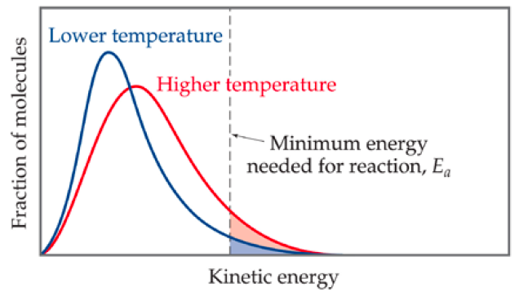

An increase in concentration causes the rate of reaction to increase by increasing the collision frequency because the number of particles per unit volume increases so the collision frequency increases.
An increase in pressure causes the rate of reaction to increase by increasing the collision frequency because the number of particles per unit volume increases so the collision frequency increases. The pressure of a system is generally increased by reducing its volume.
Catalysts provide an alternative reaction pathway, usually by introducing an extra step into the reaction, which has a lower activation energy than the uncatalysed reaction. A catalyst is a substance which changes the rate of a chemical reaction without itself being chemically altered at the end of the reaction.

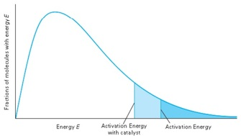

Going Deeper
Describe two experimental methods for measuring the rate of a chemical reaction.

c. Dynamic Equilibrium
Dynamic = the reaction has not stopped; it is simply moving in both directions at the same rate.
Equilibrium = the amount of reactants and products in the system is staying the same.
In reversible reactions, the rate of the forward reaction decreases and the rate of the reverse reaction increases. Eventually, the reaction will reach a stage where both forward and backward reactions are proceeding at the same rate. At this stage, a dynamic equilibrium has been reached.
A closed system is one from which reactants and products cannot escape. In closed systems the forward and reverse reactions continue until dynamic equilibrium is reached. All reactions in a closed system are therefore reversible.

An open system is one from which reactants and products can escape. In an open system, the products are removed as soon as they are formed, so the reverse reaction is not able to take place. Such reactions never reach equilibrium, but proceed until all the reactions have been converted into products.
Going Deeper
When nitrogen and hydrogen react to form ammonia, the reaction can reach a dynamic equilibrium. Explain what is meant by dynamic equilibrium, with reference to the reaction described.

d. Le Chatelier’s Principle
If a constraint is imposed on a system at equilibrium, then the system will respond in such a way as to counteract the effect of that constraint.
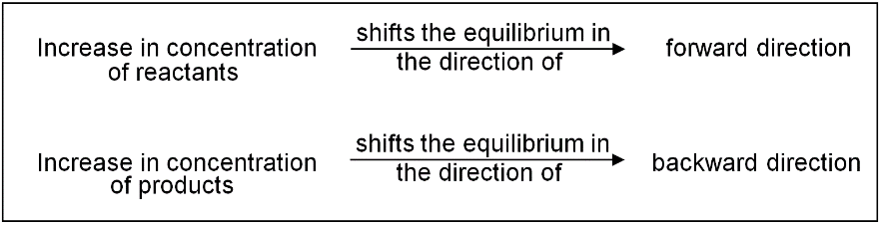
If the conditions are changed after equilibrium has been established, the system may no longer be at equilibrium and may move in one direction or another to re-establish equilibrium. The direction in which the system will move to re-establish equilibrium can be predicted by Le Chatelier's principle.

Le Chatelier's principle predicts that if the pressure of the system is increased, the system will move towards the side which has fewer gas moles. If the pressure of the system is decreased, the system will move towards the side which has more gas moles.
Le Chatelier's principle predicts that an increase in temperature will favour the endothermic reaction, and that a decrease in temperature will favour the exothermic reaction.
The addition of a catalyst will have no effect on the position of equilibrium. It will increase the rate of the forward and reverse reactions, but by the same amount. The position of equilibrium will therefore be unchanged. As the position of equilibrium is unchanged, it follows that adding a catalyst has no effect on the equilibrium constant.
Going Deeper
Many industrial ammonia plants operate at a compromise temperature of about 800 K. State and explain, using Le Chatelier’s principle, one advantage, other than cost, of using a temperature lower than 800 K.

PiXL Independence: Thinking Hard Model

Name of Topic: __________________________________________________________________________________________________
Name: __________________________________________________________________________________________________
Class: __________________________________________________________________________________________________

Take a section of the text and do the following:

- Prioritise: Underline the three most important sentences here. Rank 1-3, briefly explain number 1. Cross out the least important sentence.

- Reduce: Reduce the key information into 12 words.

- Transform: Transform this information into 4 pictures or images (no words allowed).

- Categorise: Sort this information into three categories. Highlight and think of a suitable title for each category.

- Extend: Write down three questions you’d like to ask an expert in this subject.

PiXL Independence: Quizzing

Name of Topic: __________________________________________________________________________________________________
Name: __________________________________________________________________________________________________
Class: __________________________________________________________________________________________________
Read the text and come up with 20 questions to ask someone about the text.
 | Question | Answer
1
2
3
4
5
6
7
8
9
10
11
12
13
14
15
16
17
18
19
20

Reading List
Periodic Tales: The Curious Lives of the Elements (Paperback) Hugh Aldersey-Williams
ISBN-10: 0141041455
http://bit.ly/pixlchembook1

This book covers the chemical elements, where they come from and how they are used. There are loads of fascinating insights into uses for chemicals you would have never even thought about.
The Science of Everyday Life: Why Teapots Dribble, Toast Burns and Light Bulbs Shine (Hardback) Marty Jopson
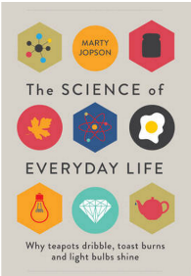
ISBN-10: 1782434186
http://bit.ly/pixlchembook2

The title says it all really, lots of interesting stuff about the things around you home!

Bad Science (Paperback) Ben Goldacre
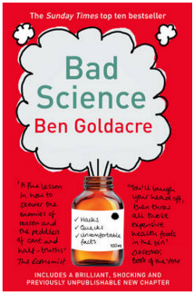
ISBN-10: 000728487X
http://bit.ly/pixlchembook3
Here Ben Goldacre takes apart anyone who published bad / misleading or dodgy science – this book will make you think about everything the advertising industry tries to sell you by making it sound ‘sciency’.

Calculations in AS/A Level Chemistry (Paperback) Jim Clark
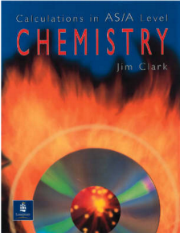
ISBN-10: 0582411270
http://bit.ly/pixlchembook4
If you struggle with the calculations side of chemistry, this is the book for you. Covers all the possible calculations you are ever likely to come across. Brought to you by the same guy who wrote the excellent chemguide.co.uk website.

Watching List
Rough science – the Open University – 34 episodes available
Real scientists are ‘stranded’ on an island and are given scientific problems to solve using only what they can find on the island.
Great fun if you like to see how science is used in solving problems.
There are six series in total
http://bit.ly/pixlchemvid1a
http://www.dailymotion.com/playlist/x2igjq_Rough-Science_rough-science-full-series/1#video=xxw6pr
or
http://bit.ly/pixlchemvid1b
https://www.youtube.com/watch?v=lUoDWAt259I
A thread of quicksilver – The Open University
A brilliant history of the most mysterious of elements – mercury. This program shows you how a single substance led to empires and war, as well as showing you come of the cooler properties of mercury.
http://bit.ly/pixlchemvid2
https://www.youtube.com/watch?v=t46lvTxHHTA
10 weird and wonderful chemical reactions
10 good demonstration reactions, can you work out the chemistry of …. any… of them?
http://bit.ly/pixlchemvid3
https://www.youtube.com/watch?v=0Bt6RPP2ANI
Chemistry in the Movies
Dantes Peak 1997: Volcano disaster movie.
Use the link to look at the Science of acids and how this links to the movie. http://www.open.edu/openlearn/science-maths-technology/science/chemistry/dantes-peak
http://www.flickclip.com/flicks/dantespeak1.html
http://www.flickclip.com/flicks/dantespeak5.html
Fantastic 4 2005 &2015: Superhero movie

Michio Kaku explains the “real” science behind fantastic four http://nerdist.com/michio-kaku-explains-the-real-science-behind-fantastic-four/

http://www.flickclip.com/flicks/fantastic4.html

© The PiXL Club Ltd. September 2018
This resource is strictly for the use of member schools for as long as they remain members of The PiXL Club. It may not be copied, sold, or transferred to a third party or used by the school after membership ceases. Until such time it may be freely used within the member school.
All opinions and contributions are those of the authors. The contents of this resource are not connected with, or endorsed by, any other company, organisation or institution.
PiXL Club Ltd endeavour to trace and contact copyright owners. If there are any inadvertent omissions or errors in the acknowledgements or usage, this is unintended and PiXL will remedy these on written notification.

