A Level Media Studies
Exam Board: Eduqas
Chestnut Grove
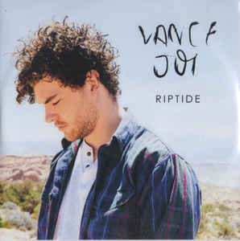
2020-2022
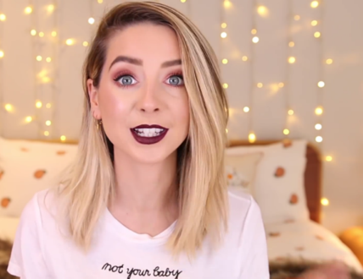
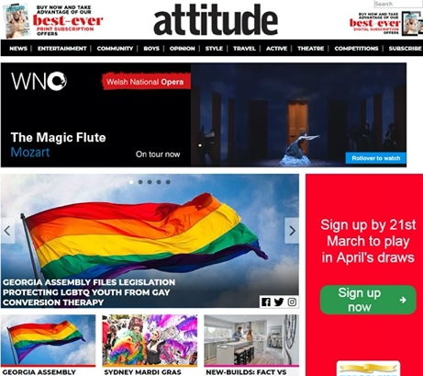
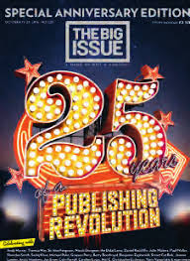
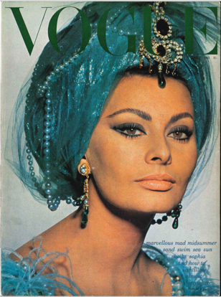
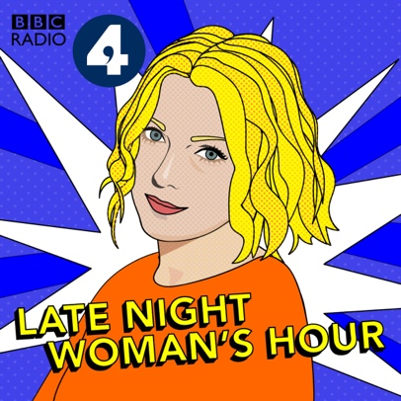
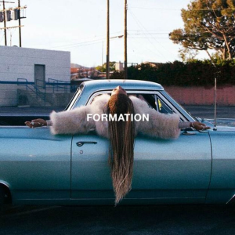
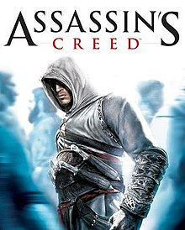
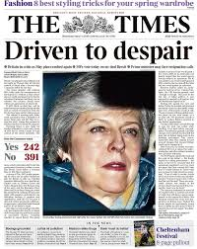
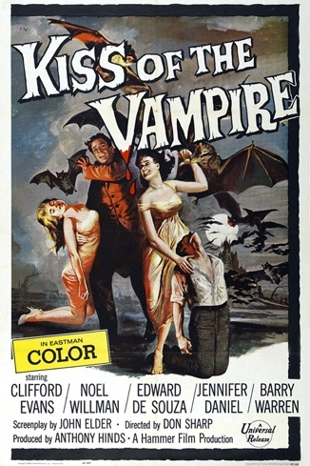
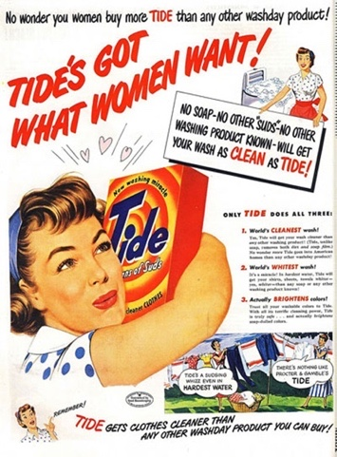

Welcome to A Level Media Studies

Media Studies is a diverse and interesting course that applies key concepts from philosophy, psychology, sociology and literary criticism to journalism and popular culture. Its analytical, essay-based structure encourages critical thinking and asks students to create arguments from different viewpoints, taking into consideration gender, class, ethnicity, sexuality and disability.

Subject: Media Studies
Examination Board: Eduqas
Paper 1  What’s assessed?  Questions will focus on issues and debates in the media such as gender stereotypes or celebrity culture.  How it's assessed  Component 1: Media Products, Industries and Audiences Written examination: 2 hours 15 minutes  35% of qualification  Code: A680U10-1  The examination assesses media language, representation, media industries, audiences and media contexts. It consists of two sections:  Questions  Section A: Analysing Media Language and Representation (45 marks)  This section assesses media language and representation in relation to two of the following media forms: advertising, marketing, music video or newspapers.  - one question assessing media language in relation to an unseen audio-visual or print resource  - one extended response comparison question assessing representation in one set product and an unseen audio-visual or print resource in relation to media contexts.  Section B: Understanding Media Industries and Audiences  This section assesses two of the following media forms – advertising, marketing, film, newspapers, radio, video games – and media contexts.  - one stepped question on media industries  - one stepped question on audiences. | Students will learn and apply the media studies key concepts  • Media language  • Ideas/messages  • Genre  • Representation (including positive and negative stereotypes and countertypes)  • Media audiences  • Narrative – story plots and structures  Students will develop their ability to be ‘media literate’, to identify and discuss the techniques used by media producers to shape the material. Students will then go on to deeper levels of analysis by applying media theories and relating the media to wider social, political and economic factors such as the impact of feminism or Brexit, for example.
Paper 2  What's assessed?  Questions will focus on the close and in-depth analysis of media products.  How it's assessed  Component 2: Media Forms and Products in Depth Written examination: 2 hours 30 minutes  35% of qualification  Code: A680U20-1  Questions  Section A – Television in the Global Age. (30 marks)  - There will be one two-part question or one extended response question.  Section B – Magazines: Mainstream and Alternative Media. (30 marks)  - There will be one two-part question or one extended response question.  Section C – Media in the Online Age (30 marks)  - There will be one two-part question or one extended response question. | A research and investigation approach to the development of the mass media over time. The exam board will provide topics and themes to be investigated.  Students will also study the texts in their historical contexts and from the perspective of critical theories such as feminism or audience theories.  The exam will require students to analyse the media from an historical perspective, again using their research during the course.
Non Exam Assessment: Creating a media product (Coursework)  What's assessed?  Application of knowledge and understanding of the media studies theoretical framework.  Practical skills relating to the media format of their choice.  How it's assessed  A choice of topics related to the over-arching (annually changing) theme  An individual cross-media production based on two forms in response to a choice of briefs set by the exam board, applying knowledge and understanding of the theoretical framework and digital convergence  30% of A-level  Assessed by teachers  Moderated by Eduqas  Tasks  Students produce:  A statement of intent  Cross-media products such as a website, broadcast sequence or magazine pages made for an intended audience. | Students will be given a brief (instructions for the task) which they need to complete such as producing:  • A television sequence  • Magazine pages  • An advertising or marketing campaign  • Radio broadcast  • Newspaper pages  • Web based material such as a site or social media products  • Video game(s)  The work will be assessed according to its creativity, technical polish, application of the typical codes and conventions of the form, consideration of purpose and target audience  Students will also submit a statement of intent – a rationale – which uses research and explains the aims and target audience for the material.

What do we study?

Component 1, Section A - Analysing Media Language and Representation
In this section, learners will analyse media language, considering how elements of media language incorporate viewpoints and ideologies, the significance of genre and how audiences may respond to media language. Learners will consider the factors that influence representations and will explore representations of events, issues, individuals and social groups in the media, using relevant theoretical perspectives or theories in their analysis of media products. In addition, learners will consider how representations relate to relevant contexts of media.
Learners will develop the ability to:
- analyse critically and compare how media products, including products outside the commercial mainstream, construct and communicate meanings through the interaction of media language and audience response
- use a range of complex theories of media studies and use specialist subject- specific terminology appropriately in a developed way
- debate key questions relating to the social, cultural, political and economic role of the media through discursive writing
- construct and develop a sustained line of reasoning which is coherent, relevant, substantiated and logically structured in an extended response.
Advertising and Marketing | Music Video | Newspapers
Tide print advertisement (1950s)  and  WaterAid audio-visual advertisement (2016) https://www.youtube.com/watc h?v=Uiy3dkTwPcQ  and Kiss of the Vampire film poster (1963) | Formation, Beyoncé* (2016) https://www.youtube.com/w atch?v=WDZJPJV__bQ  or  Dream, Dizzee Rascal (2004) https://www.youtube.com/w atch?v=2AAhc4auA7A  and  Riptide, Vance Joy (2013) https://www.youtube.com/w atch?v=uJ_  1HMAGb4k | Daily Mirror,  March 13, 2019 front page and article on ‘Brexit’ vote  and  The Times, March 13, 2019 front page
Component 1, Section B - Understanding Media Industries and Audiences
In this section, learners will develop knowledge and understanding of key aspects of media industries, including the significance of ownership and funding, the role of regulation in global production and distribution, the impact of digitally convergent platforms and the effect of individual producers on media industries. In addition, learners will study media audiences, considering aspects such as the targeting of mass and specialised audiences, the categorisation and construction of audiences, as well as how audiences' use of and responses to the media reflect identity and social, cultural and historical circumstances.
Advertising *only studied in relation to audiences | Film (cross-media study, including film marketing) **only studied in relation to industries | Newspapers
Tide print advertisement (1950s)  and  WaterAid audio-visual advertisement (2016)  https://www.youtube.com/ watch?v=Uiy3dkTwPcQ | Black Panther (2018)  and  I, Daniel Blake (2016) | Daily Mirror  and  The Times
Radio | Video Games
Late Night Woman's Hour  https://www.bbc.co.uk/programmes/p02zhq5l | Assassin’s Creed franchise

Component 2

Section A: Television in the Global Age
Television today is a global industry. The international popularity of genres like Nordic noir, the global reach of broadcasters like HBO, and the growing number of international co-productions reflect the increasingly transnational outlook of television in the global age.
Through an in-depth study of two contrasting programmes produced in different social and cultural contexts, learners will explore the dynamics that shape contemporary television production, distribution and circulation. The role of public service broadcasting in a global marketplace will be considered, as learners will explore the significance of the economic and industry contexts in which the set products are produced. The way in which the television industry is regulated and the marketing strategies used to promote the set product will also be investigated. Learners will also have opportunities to explore how the television audience is defined, constructed and targeted on both a national and a global scale.
In addition, the particular appeal of the programmes for audiences will be investigated, and issues such as fandom and the way in which audiences use media texts will also be considered.

Option 3
The Jinx: The Life and Deaths of Roberst Dust (US)
Episode 1: ‘Chapter 1: A Body in the Bay’ (2015)
Original Broadcaster: HBO
UK Broadcaster: Sky Atlantic
No Burqas Behind Bars
(Sweden)
(2013)
Original Broadcaster: NRK
Swedish Broadcaster: SVT1
UK Broadcaster: BBC World News

Section B: Magazines - Mainstream and Alternative Media
The magazine industry in the UK is a highly challenging media environment, with thousands of titles competing for readers and market space. Here, learners will study two magazines in depth, developing an understanding of the contextual factors that shape their production, distribution, circulation and consumption, as well as considering the historical, social, and cultural significance of the representations they offer. Learners will also explore how media language incorporates viewpoints and ideologies.

Option 3
Vogue
(July 1965)
(Conde Nast)
The Big Issue
(Oct 17-23 2016, No.1227)
(Dennis & The Big Issue Ltd)

Section C: Media in the Online Age
In a world increasingly dominated by digital technology, online, social and participatory media have become an integral part of the contemporary media landscape. The growing cultural significance of online platforms is evident in the number of subscribers that bloggers and YouTubers like Zoe Sugg (Zoella) attract and in the amount of web traffic that the websites of online newspapers and magazines generate.
Through an in-depth study of two contrasting online products, learners will look at the role played by blogs and websites in the media today, exploring the way in which these convergent media platforms increasingly overlap, as well as investigating the potential that they offer for self- representation. The changing relationship between media producers and audiences will be considered here, as learners will examine the idea that media consumers have now become producers who regularly and actively participate in the creation and dissemination of media content online.
The impact of digitally convergent media platforms on media production, distribution and circulation will also be explored, as learners will study an online magazine produced for a minority group, considering the way in which digital platforms can be used to reach specialised audiences. These set products can be seen to demonstrate significant emerging developments in the media, reflecting the ongoing impact of technology on media language and audience interaction.

Option 2
Zoella/Zoe Sugg
https://www.zoella.co.uk/
https://www.youtube.com/user/zoella280390
https://www.youtube.com/channel/UCrUbqTCagwsaP2F mr0p1TsA
Attitude
http://attitude.co.uk/

Theories

Learners will develop their knowledge and understanding of the theoretical framework and the following theories.

Media Language Theories | Representation Theories
Semiotics (Roland Barthes) | Representation Theory (Stuart Hall)
GenryeTheory (Steve Neale) | Identity Theory (David Gauntlett)
Structuralism (Claude Lévi-Strauss) | Feminist Theory (Liesbet Van Zoonen) (Bell Hooks)
Narratology (Todorov) | Ethnicity and Postcolonial Theory (Paul Gilroy)
Post Modernism (Jean Baudrillard) | Gender Performativity (Judith Butler)

Media Industry Theories | Media Audience Theories
Power and Media Industries (Curran and Seaton) | Media Effects (Bandura)
Regulation (Livingstone and Lunt) | Cultivation Theory (Gerbner)
Cultural Industries (Hesmondhalgh) | Reception Theory (Hall)
 | Fandom Theory (Jenkins)
 | End of Audience (Shirky)

Aims of the course
The media plays a central role in culture, society and politics and how media products shape our perceptions of the world through the representations, ideas and points of view they offer.
The course offers learners the opportunity to develop a thorough and in depth understanding of these key issues, using a comprehensive theoretical framework and a variety of advanced theoretical approaches and theories to support critical exploration and reflection, analysis and debate. The study of a wide range of rich and stimulating media products is central to the specification, offering opportunities for detailed analysis of how the media communicate meanings in a variety of forms. Learners will work from the product outwards to debate key critical questions related to the social, cultural, political and economic role of the media. Through studying media products holistically in relation to all areas of the theoretical framework, learners will engage with the dynamic relationships between media products, media industries and audiences. Learners will also consider established media forms alongside more contemporary forms, developing an awareness of emerging and evolving media.
What students can expect from the course:
• To learn how to critically understand and evaluate media material such as TV drama, advertising and the news
• An insight into the ways in which the media can shape social and political attitudes and values
• An understanding of the processes involved in producing media content across a range of platforms, including TV broadcasts, web-based material, the press and magazines
• How to create your own media products, from the original idea right through each stage of production to the finished article
• An overview of the historical development of the media by comparing ‘vintage’ material to contemporary products
• To learn how to be a critical and inquisitive student of the mass media in the 21st century
Skills and requirements at A Level
In analysing media products, learners will be required to:
- analyse critically and compare how media products, including products outside the commercial mainstream, construct and communicate meanings through the interaction of media language and audience response
- use and reflect critically upon a range of complex theories of media studies and use specialist subject-specific terminology appropriately in a developed way
- debate critically key questions relating to the social, cultural, political and economic role of the media through discursive writing.
In creating media products, learners will be required to:
- apply knowledge and understanding of media language, representation, media industries and audiences to a cross-media production
- apply knowledge and understanding of the digitally convergent nature of contemporary media
- use media language across media forms to express and communicate meaning to an intended audience.

Assessment Objectives
AO1
Demonstrate knowledge and understanding of:
- the theoretical framework of media
- contexts of media and their influence on media products and processes.
AO2
Apply knowledge and understanding of the theoretical framework of media to:
- analyse media products, including in relation to their contexts and through the use of academic theories
- evaluate academic theories
- make judgements and draw conclusions.
AO3
Create media products for an intended audience, by applying knowledge and understanding of the theoretical framework of media to communicate meaning.
The table below shows the weighting of each assessment objective for each component and for the qualification as a whole.
 | Component 1 | Component 2 | Component 3 | Total
AO1 | 17.5% | 17.5% | - | 35%
AO2 | 17.5% | 17.5% | - | 35%
AO3 | - | - | 30% | 30%
Total | 35% | 35% | 30% | 100%

Expectations of A Level Students

Organisation:

You should keep your work in an exercise book (one for each teacher) and it should be well organised. All class work, homework and revision notes should be kept here. You will need this in your lessons! Your book will be checked at least once every half term to make sure that it is up to standard.

Attendance:

It is crucial that you attend all lessons promptly in order to cover the course. If you are absent we will need you to catch up the work missed in your private study periods or after school. If you do miss a lesson, you are still required to complete the relevant homework on time.

Workload:

You should expect two hour’s work from each lesson with each teacher. This could be wider research, written work or responding to exam questions.
It is your responsibility to ensure that all set texts are fully annotated and are in your book as you will need access to these in each lesson.

Written homework is mostly planning for and responding to exam-style questions. You will be expected to respond to an extended exam question or a stepped-question every two weeks, for each teacher. We will deep mark two of these responses every half term, and you will self- and peer-assess other answers, ensuring that you are familiar with the mark scheme and able to apply it effectively.

Programme of Study

Year 12

 | Teacher 1 | Teacher 2
Autumn 1 | Film Industry  Black Panther and I, Daniel Blake | Print Advertising  Kiss of the Vampire and Tide
Autumn PPE: Paper 1 (Reduced)
Autumn 2 | Music Videos  Riptide and Formation | Audio Visual Advertising  WaterAid
Spring 1 | Video Games  Assassins Creed | Newspapers  The Mirror
Spring 2 | Radio  Late Night Woman’s Hour | Newspapers  The Times
Spring PPE: Paper 1
Summer 1 | Paper 1  Unseen and exam practice | Paper 1  Unseen and exam practice
Summer 2 | Paper 1 | Paper 1

Year 13

 | Teacher 1 | Teacher 2
Autumn 1 | Coursework | Magazines  Vogue and The Big Issue
Autumn PPE: Paper 1
Autumn 2 | Coursework | Television in the Modern Age  The Jinx and No Burqas Behind Bars
Spring 1 | Online  Zoella/Zoe Sugg and Attitude | Paper 2
Spring 2 | Revision | Revision
Spring PPE: Paper 1 and Paper 2
Summer 1 | Revision/exams | Revision/exams

