Biology6 Mark
Questions

CGP
Describe the path taken by a nerve impulse in this reflex, from stimulus to response. You should refer to both neurones and synapses in your answer.
In this question you will be assessed on the quality of your English, the organisation of your ideas and your use of appropriate specialist vocabulary.

..................................................................................................................................................................................................................................................................................................................................................................................................................... .....................................................................................................................................................................................................................................................................................................................................................................................................................
.....................................................................................................................................................................................................................................................................................................................................................................................................................
.......................................................................................................................................
(6 marks)

Mark Scheme:
Describe the path taken by a nerve impulse in this reflex, from stimulus to response. You should refer to both neurones and synapses in your answer.
0 marks: No mention of the path taken by the nerve impulse.
1-2 marks: A brief outline of some of the path taken by the nerve impulse, with reference to either neurones or synapses.
3-4 marks: A description of most the path taken by the nerve impulse, with reference to both neurones and synapses. The answer has a logical structure and spelling, grammar and punctuation are mostly correct.
5-6 marks: A description of the complete path taken by the nerve impulse (from stimulus to response). Includes reference to both neurones and synapses. The answer has a logical structure and uses correct spelling, grammar and punctuation.
Here are some points your answer may include:
The pain stimulus is detected by receptors in the skin.
The impulse travels along a sensory neurone to the central nervous system/spinal cord.
When the impulse reaches a synapse between the sensory neurone and a relay neurone, it triggers chemicals to be released.
These chemicals cause impulses to be sent along the relay neurone.
When the impulse reaches a synapse between the relay neurone and a motor neurone, chemicals are released again which cause impulses to be sent along the motor neurone.
The impulse then reaches the muscle, which contracts to move your hand away from the course of pain.

CGP
The cells of the heart need a constant supply of blood. If the coronary arteries providing that blood become narrowed or restricted, a person has a greater risk of suffering a heart attack.
Describe how the coronary arteries can become narrowed and explain how this can lead to a heart attack.
In this question you will be assessed on the quality of your English, the organisation of your ideas and your use of appropriate specialist vocabulary.

..................................................................................................................................................................................................................................................................................................................................................................................................................... .....................................................................................................................................................................................................................................................................................................................................................................................................................
.....................................................................................................................................................................................................................................................................................................................................................................................................................
.......................................................................................................................................
(6 marks)

Mark Scheme:
The cells of the heart need a constant supply of blood. If the coronary arteries providing that blood become narrowed or restricted, a person has a greater risk of suffering a heart attack.
Describe how the coronary arteries can become narrowed and explain how this can lead to a heart attack.
0 marks: No mention of how coronary arteries can become narrowed or how this can lead to a heart attack.
1-2 marks: A brief outline of how arteries can become narrowed, with no explanation for how this can lead to a heart attack.
3-4 marks: A description of how arteries can become narrowed, with some explanation for how this can lead to a heart attack. The answer has a logical structure and spelling, grammar and punctuation are mostly correct.
5-6 marks: A clear, full and detailed description of how arteries can become narrowed, with a full explanation of how this can lead to a heart attack. The answer has a logical structure and uses correct spelling, grammar and punctuation.
Here are some points your answer may include:
Eating a diet high in saturated fat has been linked to high levels of cholesterol in the blood.
If there is too much cholesterol in the blood it can start to build up in the coronary arteries. This causes plaques to form in the artery walls. Plaques narrow the arteries and restrict the flow of blood.
The coronary arteries can become narrowed through the formation of plaques.
Narrowed coronary arteries can lead to a heart attack. This is because blood flow to the heart is restricted and the heart muscle receives less oxygen.
A thrombosis (blood clot) may further restrict or block blood flow.
If the flow of blood to the heart is completely blocked, an area of the heart will be cut off from its oxygen supply. This can cause a heart attack.

Jun 2012 B1B2B3 – Foundation

Mark Scheme:

Jun 2012 B1B2B3 – Higher

Mark Scheme:

B1C1P1 Specimen - F

Basil thinks that his geranium shoots grow towards light.
He does an experiment to test this.

Method
I left one plant locked in a dark cupboard for one week.
I left another plant on my desk in a classroom for two weeks and watered it every day.
Look at the diagrams of the plants at the end of the experiment.
Based on his evidence Basil concludes that geranium shoots do grow towards the light, because the plant in the light grew better.
Is Basil right to draw this conclusion?
Evaluate his method and his conclusion.
 The quality of written communication will be assessed in your answer to this question.
.....................................................................................................................................................
.....................................................................................................................................................
.....................................................................................................................................................
.....................................................................................................................................................
.....................................................................................................................................................
.....................................................................................................................................................
.....................................................................................................................................................
.....................................................................................................................................................
.....................................................................................................................................................
................................................................................................................................................ [6]
[Total: 7]

Level 3  Answer thoroughly evaluates both conclusion and method, in terms of not testing directional growth, and applies knowledge of how to conduct this experiment to discuss in detail the flaws in the experimental method outlined including lack of unidirectional light and control of variables. All information in answer is relevant, clear, organised and presented in a structured and coherent format. Specialist terms are used appropriately. Few, if any, errors in grammar, punctuation and spelling.  (5–6 marks)  Level 2  A limited evaluation of conclusion and method, and applies knowledge of how to conduct this experiment to discuss specific flaws in the method including timing and watering. For the most part the information is relevant and presented in a structured and coherent format. Specialist terms are used for the most part appropriately. There are occasional errors in grammar, punctuation and spelling.  (3–4 marks)  Level 1  An incomplete answer, simple evaluation in terms of conclusion not right, applies knowledge to experimental method to identify method was not a ‘fair test’. Answer may be simplistic. There may be limited use of specialist terms. Errors of grammar, punctuation and spelling prevent communication of the science.  (1–2 marks)  Level 0  Insufficient or irrelevant science. Answer not worthy of credit.  (0 marks) |  | 6 | relevant points include:  - Basil is not right to draw this conclusion based on his evidence  evaluation of conclusion  - idea that conclusion not valid / not based on evidence  - because experiment did not test directional growth  - experiment was testing whether plant grows in light or dark  evaluation of method  - not enough detail to allow method to be followed  - reference to condition of unidirectional light required / idea that should have blocked out light from all but one direction  - reference to not watering both batches equally  - reference to not leaving them to grow for the same length of time  - idea of not a ‘fair test’  - reference to not doing repeats / controlling variables  - reference to variables that were not controlled eg size of plant at the start  allow examples of how the experiment should have been done
Total | 7
Mark Scheme:

B1C1P1 Specimen – H

This article appeared in a recent newspaper.

Mary has type 1 diabetes.
She eats a very large meal.
Explain why using the monitor will help her.
 The quality of written communication will be assessed in your answer to this question.
............................................................................................................................................................
............................................................................................................................................................
............................................................................................................................................................
............................................................................................................................................................
............................................................................................................................................................
............................................................................................................................................................
............................................................................................................................................................
....................................................................................................................................................... [6]
[Total: 6]

Mark Scheme
Level 3  Answer comprehensively explains the effects of diabetes on Mary and applies understanding of diabetes to clearly explain why the monitor will help in the context of a very large meal. All information in answer is relevant, clear, organised and presented in a structured and coherent format. Specialist terms are used appropriately. Few, if any, errors in grammar, punctuation and spelling.  (5-6 marks)  Level 2  Answer explains some of the effects of diabetes on Mary and applies understanding of diabetes to explain the need to inject insulin but the importance of regulating the dose is not explained. For the most part the information is relevant and presented in a structured and coherent format. Specialist terms are used for the most part appropriately. There are occasional errors in grammar, punctuation and spelling.  (3-4 marks)  Level 1  Answer identifies the effects of diabetes in terms of being unable to regulate blood glucose. There may be limited use of specialist terms. Errors of grammar, punctuation and spelling prevent communication of the science.  (1-2 marks)  Level 0  Insufficient or irrelevant science. Answer not worthy of credit.  (0 marks) | 6 | relevant points include:  - Mary cannot produce enough insulin  - she cannot therefore regulate her blood glucose level  - idea of homeostasis  - after the meal blood glucose level is too high  - reference to problems caused by hyperglycaemia  - alarm will sound to tell her so that she can inject herself with insulin  - she needs this insulin injection to regulate blood glucose  - important to match the dose to the blood glucose level  - device measures very regularly so will give more frequent measurements so she knows almost immediately if the level is too high  - she doesn’t have to cut herself or use blood to detect her blood glucose level reducing risk of infection/improving quality of life  - automatically tests without her having to remember  - once she has injected insulin it will convert glucose to glycogen for storage in the liver  - reducing blood glucose level  allow blood sugar instead of blood glucose

B1C1P1 Jan 2012 F

Mark Scheme:

B1C1P1 Jan 2012 – H

Mark Scheme:

B1B2B3 Jan 2012 – H

Mark Scheme:
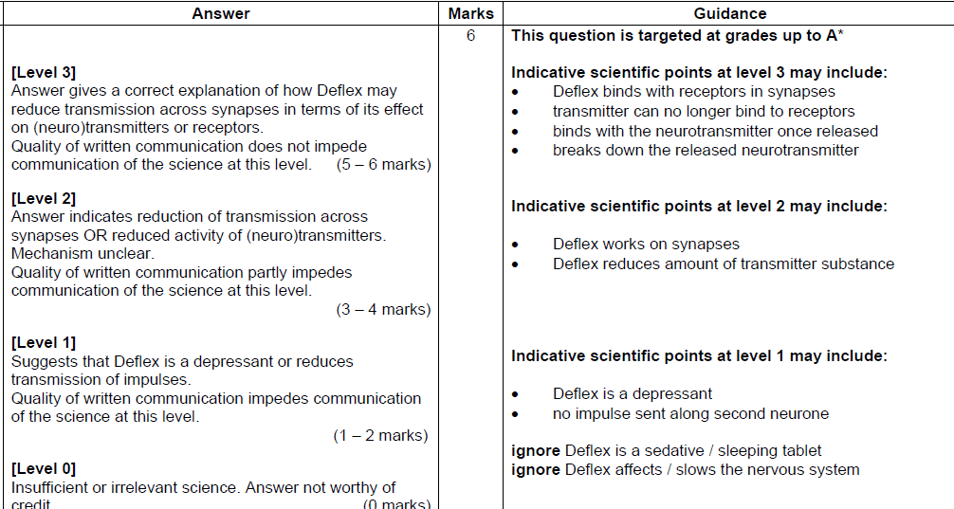

B1B2B3 Jan 2012 – F

Mark Scheme

CGP
The emperor penguin is adapted to survive in extremely cold conditions. Its adaptations to the cold include:
- Small surface area to volume ratio.
- A cold-current heat exchange system in their legs and feet.
Explain how the adaptations described above help the penguins to survive in cold conditions. Then suggest and explain further adaptations that the penguins might also have to the cold.
In this question you will be assessed on the quality of your English, the organisation of your ideas and your use of appropriate specialist vocabulary.

..................................................................................................................................................................................................................................................................................................................................................................................................................... .....................................................................................................................................................................................................................................................................................................................................................................................................................
.....................................................................................................................................................................................................................................................................................................................................................................................................................
.......................................................................................................................................
(6 marks)

Mark Scheme:
The emperor penguin is adapted to survive in extremely cold conditions. Its adaptations to the cold include:
- Small surface area to volume ratio.
- A cold-current heat exchange system in their legs and feet.
Explain how the adaptations described above help the penguins to survive in cold conditions. Then suggest and explain further adaptations that the penguins might also have to the cold.
0 marks: No explanation given for any adaptions.
1-2 marks: A brief explanation given for the penguin’s surface area to volume ratio and/or its counter-current heat exchange system. No other adaptions are suggested.
3-4 marks: An explanation is given for both the penguin’s surface area to volume ratio and counter-current heat exchange system. One or two other adaptations are suggested but little or no explanation is given for these. The answer has a logical structure and spelling, grammar and punctuation are mostly correct.
5-6 marks: A clear, full and detailed explanation given for the penguin’s surface area to volume ratio and counter-current heat exchange system. More than two other adaptations are suggested and explained in detail. The answer has a logical structure and uses correct spelling, grammar and punctuation.
Here are some points your answer may include:
A small surface area to volume ratio reduces heat loss through the surface of the skin.
The counter-current heat exchange system means that blood vessels going to and from the feet pass close to each other, allowing heat to transfer between them. Warm blood flowing in arteries to the feet transfers heat to cold blood returning to the heart in the veins. This stops cold blood from cooling down the penguin’s body.
Other adaptions that might have been suggested:
The penguins might have e.g. a thick layer of blubber/thick feathers for insulation.
The penguins might huddle together to keep warm.
The penguins might migrate to warmer areas during the winter months to avoid having to cope with the cold conditions.
The penguins might hibernate during the winter months. This saves energy as the penguin won’t have to find food or keep itself as warm as if it was active.

CGP
The chimpanzee and bonobo are two separate species that evolved from a common ancestor.
It is thought that two populations of the ancestor became isolated from each other when the Congo River formed. The population to the north of the river became chimpanzees and the population to the south became bonobos.
Use your knowledge of natural selection and speciation to suggest how the new species of chimpanzee and bonobo evolved from the same common ancestor.
In this question you will be assessed on the quality of your English, the organisation of your ideas and your use of appropriate specialist vocabulary.

..................................................................................................................................................................................................................................................................................................................................................................................................................... .....................................................................................................................................................................................................................................................................................................................................................................................................................
.....................................................................................................................................................................................................................................................................................................................................................................................................................
.......................................................................................................................................
(6 marks)

Mark Scheme:
The chimpanzee and bonobo are two separate species that evolved from a common ancestor.
It is thought that two populations of the ancestor became isolated from each other when the Congo River formed. The population to the north of the river became chimpanzees and the population to the south became bonobos.
Use your knowledge of natural selection and speciation to suggest how the new species of chimpanzee and bonobo evolved from the same common ancestor.
0 marks: No mention of how chimpanzees and bonobos have evolved from the same common ancestor.
1-2 marks: A brief outline of how chimpanzees and bonobos have evolved from the same common ancestor.
3-4 marks: Some explanation of how chimpanzees and bonobos have evolved from the same common ancestor, with reference to reproductive isolation. The answer has a logical structure and spelling, grammar and punctuation are mostly correct.
5-6 marks: A clear, full and detailed explanation of how chimpanzees and bonobos evolved from the same common ancestor, with reference to reproductive isolation. The answer has a logical structure and uses correct spelling, grammar and punctuation.
Here are some points your answer may include:
Speciation requires reproductive isolation. This is where the members of different populations are unable to interbreed to produce fertile offspring.
Reproductive isolation could have been caused by the Congo River acting as a physical barrier, making the populations to the north and south of the river geographically unable to interbreed.
Different mutations could have created different features in the two populations.
Over a long period of time, beneficial features may have spread through the populations through the process of natural selection.
Conditions to the north and south of the river may have been slightly different, so the features that were beneficial may have been different for each population.
Eventually, individuals into eh populations to the north and south of the river may have developed such different features they were no longer able to interbreed to produce fertile offspring. They became the new species of chimpanzees and bonobos.

Jun 2012 B2C2P2 – Foundation

Mark Scheme:

Jun 2012 B2C2P2 – Higher

Mark Scheme:

Jun 2012 B1B2B3 – Foundation

Mark Scheme:
Jun 2012 B1B2B3 - Higher

Mark Scheme:

B2C2P2 Specimen F

Banana plants are part of a food web.

Energy enters this food web and passes from organism to organism. Some energy is lost from the food web.
Write about how these transfers of energy happen in this food web.
 The quality of written communication will be assessed in your answer to this question.

.............................................................................................................................................
.............................................................................................................................................
.............................................................................................................................................
.............................................................................................................................................
.............................................................................................................................................
.............................................................................................................................................
.............................................................................................................................................
.............................................................................................................................................
........................................................................................................................................ [6]
[Total 12]

Mark Scheme
Level 3  Applies understanding of energy transfers to describe in detail the processes of energy capture, transfer between trophic levels and loss at all stages for the banana plant food web and clearly sequences them in the correct order. All information in answer is relevant, clear, organised and presented in a structured and coherent format. Specialist terms are used appropriately. Few, if any, errors in grammar, punctuation and spelling.  (5–6 marks)  Level 2  Answer may describe some processes and may not make the correct order clear. For the most part the information is relevant and presented in a structured and coherent format. Specialist terms are used for the most part appropriately. There are occasional errors in grammar, punctuation and spelling.  (3–4 marks)  Level 1  An incomplete answer, naming some processes without describing them and omitting other processes. Answer may be simplistic. There may be limited use of specialist terms. Errors of grammar, punctuation and spelling prevent communication of the science.  (1–2 marks)  Level 0  Insufficient or irrelevant science. Answer not worthy of credit.  (0 marks) | 6 | Relevant points include:  - energy enters the food chain from sunlight  - energy trapped by banana plants/chlorophyll in leaves of banana plants  - by photosynthesis  - energy trapped in food/sugar  then  - energy transferred from one organism to another (from producer to primary consumer) by feeding  - energy in banana plants transferred to root borers, banana aphids and banana skippers by feeding  - energy transferred from primary consumers to secondary consumers/ants and wasps  - energy transferred from secondary consumers to tertiary consumers/birds  then  - energy is lost at each stage/trophic level as it is converted into less useful forms  - examples of methods of energy loss from this food web includes excretion, heat from respiration and egestion

Mark Scheme

B1B2B3 Jan 2012 – H

Mark Scheme

B1B2B3 Jan 2012 – F
Mark Scheme

CGP
Dolly the sheep was the first mammal to be successfully cloned.
Describe the process of cloning used to produce Dolly the sheep.
In this question you will be assessed on the quality of your English, the organisation of your ideas and your use of appropriate specialist vocabulary.

..................................................................................................................................................................................................................................................................................................................................................................................................................... .....................................................................................................................................................................................................................................................................................................................................................................................................................
.....................................................................................................................................................................................................................................................................................................................................................................................................................
.......................................................................................................................................
(6 marks)

Mark Scheme:
Dolly the sheep was the first mammal to be successfully cloned.
Describe the process of cloning used to produce Dolly the sheep.
0 marks: No mention of the process of cloning used to produce Dolly.
1-2 marks: A brief outline of some of the process of cloning used to produce Dolly.
3-4 marks: A description of most of the process used to produce Dolly. The answer has a logical structure and spelling, grammar and punctuation are mostly correct.
5-6 marks: A clear, full and detailed description of the complete process used to produce Dolly. The answer has a logical structure and uses correct spelling, grammar and punctuation.
Here are some points your answer may include:
Dolly was cloned using the process of nuclear transfer.
The nucleus of a sheep’s egg was removed. This left the egg cell without any genetic material.
Another nucleus was inserted in the egg cell. This was a diploid nucleus from the body cell of another sheep and had all its genetic information.
The cell was given an electric shock to make it divide by mitosis.
The dividing cell/embryo was implanted into the uterus of a surrogate mother, where it developed until it was ready to be born. The embryo was Dolly the sheep – a clone.

CGP
Blood is transported around the body in arteries, veins and capillaries. Describe the features of these blood vessels and explain how they relate to the vessels’ functions.
In this question you will be assessed on the quality of your English, the organisation of your ideas and your use of appropriate specialist vocabulary.

..................................................................................................................................................................................................................................................................................................................................................................................................................... .....................................................................................................................................................................................................................................................................................................................................................................................................................
.....................................................................................................................................................................................................................................................................................................................................................................................................................
.......................................................................................................................................
(6 marks)

Mark Scheme:
Blood is transported around the body in arteries, veins and capillaries. Describe the features of these blood vessels and explain how they relate to the vessels’ functions.
0 marks: No mention of the features of the functions of the blood vessels or how the features relate to the vessels’ functions.
1-2 marks: A brief description of the features and/or functions of one or two blood vessels, with no mention of how the features relate to the vessels’ function.
3-4 marks: A description of the features and functions of all the blood vessels, with a brief explanation of how some of the features relate to those vessels’ functions. The answer has a logical structure and spelling, grammar and punctuation are mostly correct.
5-6 marks: A clear, detailed and full descriptions of the features and functions of all the blood vessels, with a full explanation of how all of the features relate to the vessels’ functions. The answer has a logical structure and uses correct spelling, grammar and punctuation.
Here are some points your answer may include:
Arteries carry blood away from the heart at high pressure, so the muscular walls are strong and elastic to withstand this pressure. The walls are also thick compared to the size of the lumen, again to withstand the high pressure.
Capillaries carry the blood close to every cell in the body in order to exchange substances with them. As a result they have permeable walls that are only one cell thick. This increases the rate of diffusion by decreasing the distance over which it occurs.
Veins carry blood to the heart at low pressure. This means the walls don’t need to be as thick as in arteries. They have a bigger lumen than arteries to help the blood flow despite the low pressure. They also have valves to help keep the blood flowing in the right direction despite the low pressure.

Jun 2012 B3C3P3 – Foundation

Mark Scheme:

Jun 2012 B3C3P3 – Higher

Mark Scheme:
Jun 2012 B1B2B3 – Foundation

Mark Scheme:

Jun 2012 B1B2B3 – Higher

Mark Scheme:
B3C3P3 Specimen –F

Mark Scheme:

B3C3P3 Specimen – H
This question is about genes.
Genes code for the production of proteins.
Mutations are changes to genes that can cause them to code for different proteins.
Explain how a gene codes for a protein and how a mutation can lead to a change in the protein
for which the gene codes.
 The quality of written communication will be assessed in your answer to this question.
............................................................................................................................................................
............................................................................................................................................................
............................................................................................................................................................
............................................................................................................................................................
............................................................................................................................................................
............................................................................................................................................................
............................................................................................................................................................
............................................................................................................................................................
....................................................................................................................................................... [6]
[Total: 6]

Mark Scheme:

B1B2B3 Jan 2012 – H
Mark Scheme

B1B2B3 Jan 2012 – F

Mark Scheme

CGP
The diagram below shows some of the cells in a plant leaf
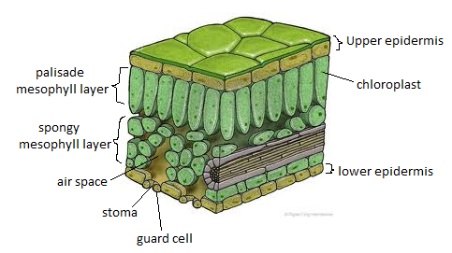
Use the diagram and your own knowledge to describe and explain how leaves are adapted for efficient photosynthesis.
In this question you will be assessed on the quality of your English, the organisation of your ideas and your use of appropriate specialist vocabulary.
..................................................................................................................................................................................................................................................................................................................................................................................................................... .....................................................................................................................................................................................................................................................................................................................................................................................................................
.....................................................................................................................................................................................................................................................................................................................................................................................................................
.......................................................................................................................................
(6 marks)
Mark Scheme:
The diagram below shows some of the cells in a plant leaf

Use the diagram and your own knowledge to describe and explain how leaves are adapted for efficient photosynthesis.
0 marks: No mention of any adaptations of leaves for efficient photosynthesis.
1-2 marks: One or two adaptation of leaves for efficient photosynthesis are briefly described, but not explained.
3-4 marks: Three or four adaptations of leaves for efficient photosynthesis are described, with some explanation. The answer has a logical structure and spelling, grammar and punctuation are mostly correct.
5-6 marks: At least five adaptations for leaves for efficient photosynthesis are described in detail and fully explained. The answer has a logical structure and uses correct spelling, grammar and punctuation.
Here are some points your answer may include:
Leaves are broad, so there’s a large surface are for the exchange of gases and light absorption.
They’re also thin, so gases and water vapour only have to diffuse a short distance to reach the photosynthesising cells.
The lower surface/epidermis of leaves is full of stomata. These let carbon dioxide and oxygen in and out.
There are guard cells surrounding each stoma to control when it opens and closes. This allows the guard to control gas exchange.
There are air spaces in the spongy mesophyll layer. These allow carbon dioxide and oxygen to move between the stomata and the photosynthesising cells.
There is a large internal surface are to volume ratio to provide a large area for gas exchange.
There are lots of chloroplasts, which contain chlorophyll and other photosynthetic pigments to absorb different wavelengths of light. This allows plant cells to make the most of the Sun’s energy by absorbing as much of it as possible.
The cells containing the most chloroplasts are arranged in the palisade mesophyll layer near the top of the leaf where they can get the most light.
The upper epidermis is transparent to that light can pass through it to the chloroplasts in the palisade mesophyll layer.
CGP
Forestry plantations are a type of artificial ecosystem. They tend to have a much lower biodiversity than natural ecosystems such are woodlands.
The picture on the left shows an artificial forestry planation.]the picture on the right shows a native woodland.
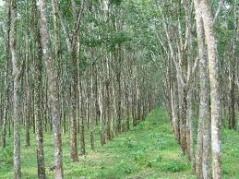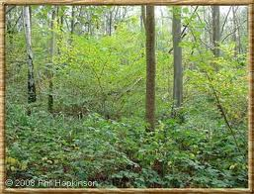
Explain the difference in the biodiversity of forestry plantations and native woodlands.
In this question you will be assessed on the quality of your English, the organisation of your ideas and your use of appropriate specialist vocabulary.

..................................................................................................................................................................................................................................................................................................................................................................................................................... .....................................................................................................................................................................................................................................................................................................................................................................................................................
.....................................................................................................................................................................................................................................................................................................................................................................................................................
.......................................................................................................................................
(6 marks)
Mark scheme:
Forestry plantations are a type of artificial ecosystem. They tend to have a much lower biodiversity than natural ecosystems such are woodlands.
The picture on the left shows an artificial forestry planation.]the picture on the right shows a native woodland.

Explain the difference in the biodiversity of forestry plantations and native woodlands.
0 marks: No explanation given for the difference in the biodiversity of forestry plantations and native woodlands.
1-2 marks: A brief explanation of one or two reasons for the difference in the biodiversity of forestry plantations and native woodlands.
3-4 marks: Some explanations of three or four reasons for the difference in the biodiversity of forestry plantations and native woodlands. The answer has a logical structure and spelling, grammar and punctuation are mostly correct.
5-6 marks: A clear, full and detailed explanation of at least five reasons for the difference in the biodiversity of forestry plantations and native woodlands. The answer has a logical structure and uses correct spelling, grammar and punctuation.
Here are some points your answer may include:
In forestry plantations one often non-native) species of tree is planted for timber, whereas native woodlands have a variety of tree species.
Blocks of trees are planted at the same time in forestry plantations, so many trees are the same age, whereas in native woodlands trees and different sizes and ages.
In forestry plantations there are fewer plant species because trees are densely planted. This leaves less room and light for other plants. In native woodlands there is more light and space and so a much greater variety of plant species.
There are fewer habitats forestry plantations because there aren’t enough plant species to create them. When trees are felled, habitats are also disturbed or destroyed. There’s a much greater variety of habitats in native woodlands, for example, different trees and shrubs for birds to nest in.
In forestry plantations there are fewer animal species because there aren’t as many habitations or sources of food. In native woodlands there is a greater variety of animal species because there are many different habitats and sources of food.
B4C4P4 Specimen – F

Mark Scheme:

B4C4P4 Specimen – H

Compare the effects of increasing air movement and increasing humidity on the rate of transpiration in Jo’s plants.
Use information from the table, as well as your own calculations, to help you answer.
􀀄 The quality of your written communication will be assessed in your answer to this question.

.....................................................................................................................................................
.....................................................................................................................................................
.....................................................................................................................................................
.....................................................................................................................................................
.....................................................................................................................................................
.....................................................................................................................................................
.....................................................................................................................................................
.....................................................................................................................................................
................................................................................................................................................ [6]

Mark Scheme:

B4B5B6 Specimen – F

Compare the effects of increasing air movement and increasing humidity on the rate of
transpiration in Jo’s plants.
Use information from the table, as well as your own calculations, to help you answer.
 The quality of your written communication will be assessed in your answer to this question.

.....................................................................................................................................................
.....................................................................................................................................................
.....................................................................................................................................................
.....................................................................................................................................................
.....................................................................................................................................................
.....................................................................................................................................................
.....................................................................................................................................................
.....................................................................................................................................................
.....................................................................................................................................................
................................................................................................................................................ [6]

Mark Scheme:

Compare the effects of increasing air movement and increasing humidity on the rate of transpiration in Jo’s plants.
Use information from the table, as well as your own calculations, to help you answer.
 The quality of your written communication will be assessed in your answer to this question.
.....................................................................................................................................................
.....................................................................................................................................................
.....................................................................................................................................................
.....................................................................................................................................................
.....................................................................................................................................................
.....................................................................................................................................................
.....................................................................................................................................................
.....................................................................................................................................................
.....................................................................................................................................................
................................................................................................................................................[6]

Mark Scheme:
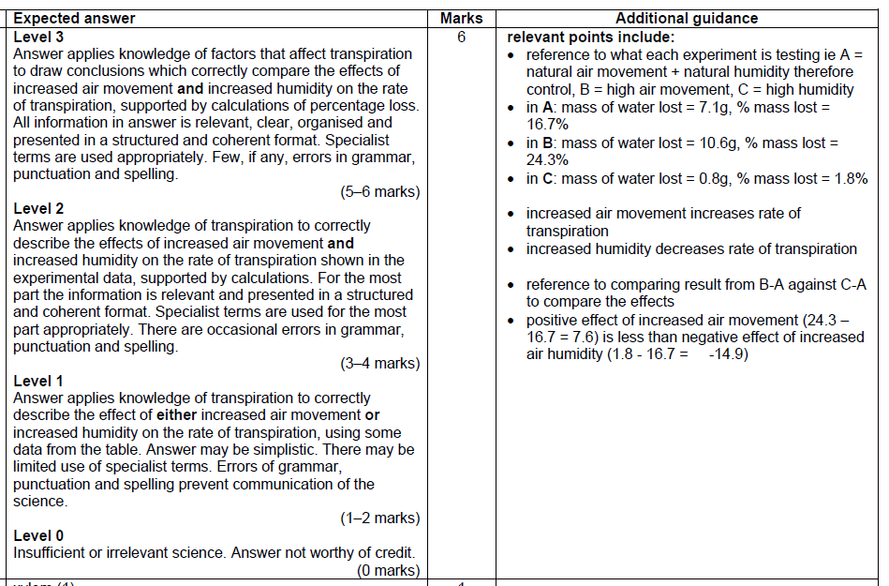

NC
Explain how this plant has become wilted. Use ideas about osmosis.

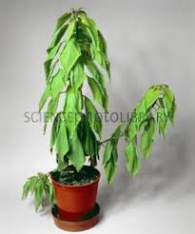

In this question you will be assessed on the quality of your English, the organisation of your ideas and your use of appropriate specialist vocabulary.

..................................................................................................................................................................................................................................................................................................................................................................................................................... .....................................................................................................................................................................................................................................................................................................................................................................................................................
.....................................................................................................................................................................................................................................................................................................................................................................................................................
.......................................................................................................................................
(6 marks)

Mark Scheme:
0 marks: No relevant information.
1-2 marks: A brief description of osmosis or wilting as a lack of water.
3-4 marks: A description of how water molecules move through the membrane of plant cells and explanation of wilting in terms of turgor pressure. The answer has a logical structure and spelling, grammar and punctuation are mostly correct.

5-6 marks: A clear and detailed explanation of how water molecule move through the membrane of plant cells, and the affect on the plant cell structure. The answer has a logical structure and uses correct spelling, grammar and punctuation.

Here are some points your answer may include:
- Water moves in and out of plant cells by osmosis through the cells membrane.
- Lack of water can cause plants to wilt.

- Water moves across a partially-permeable membrane from an area of high water concentration to an area of low water concentration.
- The membrane is partially permeable as water is small enough to pass through the pores, however, larger molecules such as sugar are too big to pass through the pores in the membrane.
- Water/turgor pressure in the cells supports the plants structure, lack of turgor pressure results in wilting.

- Movement of water across the membrane occurs due to the random movement of water particles.
- In a wilted plant water has moved from a high concentration in the plant cells to a lower concentration by random movement. This has resulted in a lack of turgor pressure in the cell. The cell is referred to as being flaccid. Eventually the cell contents will collapse away from the cell wall, referred to as a plasmolysed cell.
CGP
The menstrual cycle is controlled by the hormone FSH, oestrogen, LH and progesterone.
Describe the role of these hormones in the menstrual cycle and explain how their production and release is controlled by negative feedback.
In this question you will be assessed on the quality of your English, the organisation of your ideas and your use of appropriate specialist vocabulary.

..................................................................................................................................................................................................................................................................................................................................................................................................................... .....................................................................................................................................................................................................................................................................................................................................................................................................................
.....................................................................................................................................................................................................................................................................................................................................................................................................................
.......................................................................................................................................
(6 marks)

Mark Scheme:
The menstrual cycle is controlled by the hormone FSH, oestrogen, LH and progesterone.
Describe the role of these hormones in the menstrual cycle and explain how their production and release is controlled by negative feedback.
0 marks: No mention of the role of these hormones in the menstrual cycle or of how their production is controlled by negative feedback.
1-2 marks: The role of one or two of these hormones in the menstrual cycle is briefly described. No explanation is given for how their production is controlled by negative feedback.
3-4 marks: The role of three or four of these hormones in the menstrual cycle is described. A brief explanation is given for how their production is controlled by negative feedback. The answer has a logical structure and spelling, grammar and punctuation are mostly correct.
5-6 marks: The role of all of four of these hormones in the menstrual cycle is described clearly and in detail. A full explanation is given for how their production is controlled by negative feedback. The answer has a logical structure and uses correct spelling, grammar and punctuation.
Here are some points your answer may include:
FSH causes an egg to develop in the ovaries.
Oestrogen causes the lining of the uterus to repair/thicken and grow.
LH stimulates ovulation/the release of an egg at day 14.
Progesterone maintains the lining of the uterus. When the level of progesterone falls, the lining breaks down.
When the concentration of one hormone in the menstrual cycle becomes too high, the release of another hormone returns it to a lower level. This is negative feedback.
FSH stimulates the ovaries to release oestrogen. Oestrogen then inhibits the production of FSH, so the level of FSH falls.
LH indirectly stimulates the production of progesterone in the ovaries. Progesterone then inhibits release of LH, so the level o LH falls.
CGP
All animals need a blood circulatory system to transport materials around the body. Some, such as fish, have a single circulatory system. Others, like humans, have a double circulatory system.
Describe the two types of circulatory system and explain the advantage of a double circulatory system over a single one.
In this question you will be assessed on the quality of your English, the organisation of your ideas and your use of appropriate specialist vocabulary.

..................................................................................................................................................................................................................................................................................................................................................................................................................... .....................................................................................................................................................................................................................................................................................................................................................................................................................
.....................................................................................................................................................................................................................................................................................................................................................................................................................
.......................................................................................................................................
(6 marks)

Mark Scheme:
All animals need a blood circulatory system to transport materials around the body. Some, such as fish, have a single circulatory system. Others, like humans, have a double circulatory system.
Describe the two types of circulatory system and explain the advantage of a double circulatory system over a single one.
0 marks: No mention of either type of circulatory system.
1-2 marks: A brief description of either single or double circulatory systems. The advantage of a double circulatory system is not given.
3-4 marks: Both single and double circulatory systems are described. The advantage of a double circulatory system is broadly outlined with reference either to higher blood pressure or faster transport of materials around the body. The answer has a logical structure and spelling, grammar and punctuation are mostly correct.
5-6 marks: TA clear, full and detailed description of both single and double circulatory systems is given. The advantage of a double circulatory system is fully explained with reference to both higher blood pressure and faster transport of materials around the body. The answer has a logical structure and uses correct spelling, grammar and punctuation.
Here are some points your answer may include:
A single circulatory system involves one circuit of blood vessels from the heart. For this fish need a two-chambered heart: one chamber to receive blood and one to pump blood to the gills and the rest of the body
A double circulatory system involves two circuits of blood vessels from the heart – one to the body and one to the lungs. For this, humans need a four-chambered heart. This allows the blood to be pumped separately to, and received separately from, the lungs and the body.
An advantage of the double circulatory system is that blood pressure is much higher.
B4B5B6 Specimen – F
Lucy is a 10 year-old girl with a body mass of 22 kg.
Lucy’s parents are concerned about her growth.
Should Lucy’s parents be concerned about her growth and what factors could have affected
Lucy’s growth?
 The quality of your written communication will be assessed in your answer to this question.
.....................................................................................................................................................
.....................................................................................................................................................
.....................................................................................................................................................
.....................................................................................................................................................
.....................................................................................................................................................
.....................................................................................................................................................
.....................................................................................................................................................
.....................................................................................................................................................
.....................................................................................................................................................
................................................................................................................................................ [6]
Mark Scheme:

B4B5B6 Specimen – H

Explain why the indicator changes colour and what conclusions Anya can draw about the factors affecting the digestion of fats.
The quality of written communication will be assessed in your answer to this question.

...................................................................................................................................................................................................................................................................................................................................................................................................................................................................................................................................................................................................................................................................................................................................................................................................................................................................................................................................................................................................................................................................................................................................................................................................................................................................................................................................................................................................................................................................................................................................................................................................................[6]

Mark Scheme:
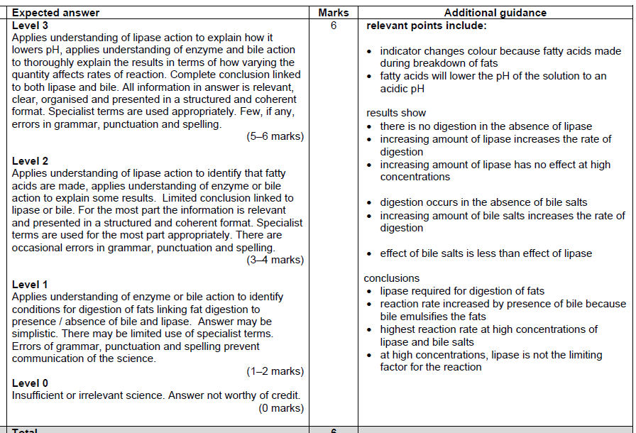

CGP
Some people regard biofuels such as biogas as a more environmentally friendly source of energy than fossil fuels. Others believe they cause equally significant problems.
Discuss the advantages and disadvantages of the use of biogas over fossil fuels.
In this question you will be assessed on the quality of your English, the organisation of your ideas and your use of appropriate specialist vocabulary.

..................................................................................................................................................................................................................................................................................................................................................................................................................... .....................................................................................................................................................................................................................................................................................................................................................................................................................
.....................................................................................................................................................................................................................................................................................................................................................................................................................
.......................................................................................................................................
(6 marks)

Mark Scheme:
Some people regard biofuels such as biogas as a more environmentally friendly source of energy than fossil fuels. Others believe they cause equally significant problems.
Discuss the advantages and disadvantages of the use of biogas over fossil fuels.
0 marks: No advantages or disadvantages of the use of biogas over fossil fuels are given.
1-2 marks: A brief outline of one or two advantages and/or disadvantages of the use of biogas over fossil fuels.
3-4 marks: Discussion of two advantages and two disadvantages of the use of biogas over fossil fuels. The answer has a logical structure and spelling, grammar and punctuation are mostly correct.
5-6 marks: A full and detailed discussion of at least three advantages and three disadvantages of the use of biogas over fossil fuels. The answer has a logical structure and uses correct spelling, grammar and punctuation.
Here are some points your answer may include:
Advantages:
If the right conditions are met, burning biogas does not cause a net increase in the level of greenhouse gases. This is because the plants that are grown to make biogas take in carbon dioxide during photosynthesis. Burning fossil fuels does cause a new increase in the level of greenhouse gases,
The biomass used to make biogas can be grown in a sustainable way. The crops which are decomposed to make biogas can be replaced quickly with new plants. By contrast, there is finite supply of fossil fuels.
Biogas is a cleaner fuel than diesel or petrol. Burning diesel or petrol produces particulates which can cause lung disease. Burning biogas does not.
Disadvantages:
Biogas does not contain as much energy as the same volume of natural gas because it is more dilute.
Burning biogas can cause a net increase in the level of greenhouse gases if the biogas is not burnt at the same rate biomass is produced/the areas of land used to grow biomass are cleared by burning the vegetation that is already there.
Growing biomass to produce biogas can lead to destruction of the habits of many plant and animal species. This is because large areas of land are sometimes cleared to grow the biomass.
The loss of habitats and a change in the availability of food caused by growing biomass for biogas might also mean that some species become extinct.

CGP
DNA fingerprinting allows samples of DNA to be compared to determine whether they come from the same person. Although it is a useful technique, there has been a debate over whether to store everyone’s DNA fingerprint on a national database.
Describe how a DNA fingerprint is made and give arguments for and against storing DNA fingerprints.
In this question you will be assessed on the quality of your English, the organisation of your ideas and your use of appropriate specialist vocabulary.

..................................................................................................................................................................................................................................................................................................................................................................................................................... .....................................................................................................................................................................................................................................................................................................................................................................................................................
.....................................................................................................................................................................................................................................................................................................................................................................................................................
.......................................................................................................................................
(6 marks)

Mark Scheme:
DNA fingerprinting allows samples of DNA to be compared to determine whether they come from the same person. Although it is a useful technique, there has been a debate over whether to store everyone’s DNA fingerprint on a national database.
Describe how a DNA fingerprint is made and give arguments for and against storing DNA fingerprints.
0 marks: No mention of how a DNA fingerprint is made or any of the arguments for or against storing DNA fingerprints.
1-2 marks: Either a brief outline of how a DNA finger print is made or an argument for or against storing DNA fingerprints.
3-4 marks: A description of how a DNA fingerprint is made, with one relevant argument either for or against storing DNS fingerprints. The answer has a logical structure and spelling, grammar and punctuation are mostly correct.
5-6 marks: A clear, full and detailed description of how a DNA fingerprint is made. At least one detailed argument for and one detailed argument against storing DNA fingerprints is given. The answer has a logical structure and uses correct spelling, grammar and punctuation.
Here are some points your answer may include:
To take a DNA fingerprint DNA must first be extracted from the cells in the sample.
Restriction enzymes are then used to cut the DNA into different sized fragments.
The DNA fragments are separated out using a process called electrophoresis. The fragments are suspended in a gel, and an electric current is passed through the gel. DNA is negatively charged, so it moves towards the positive anode.
The DN is ‘tagged’ with a radioactive probe. It is then placed onto photographic film. The film goes dark when the radioactivity is, revealing the position of the DNA fragments.
The main argument for storing DNA fingerprints is that DNA from a crime scene could be checked against everyone in the country to see whose it was. This would make solving some crimes much easier.
However, some people view storing DNA fingerprints as an invasion of privacy. They also worry over how safe the data might be, and what else it might be used for.

B4B5B6 Specimen – F
Wine is made from grapes using micro-organisms.
Describe the process by which wine is made.
 The quality of your written communication will be assessed in your answer to this question.
............................................................................................................................................................
............................................................................................................................................................
............................................................................................................................................................
............................................................................................................................................................
............................................................................................................................................................
............................................................................................................................................................
............................................................................................................................................................
............................................................................................................................................................
............................................................................................................................................................
....................................................................................................................................................... [6]

Mark Scheme

B4C4P4 Specimen – H
(b) The scientists have put a gene from another species into the potato plant. Describe how this is done, explaining how different enzymes are used in this process.
The quality of written communication will be assessed in your answer to this question.

..................................................................................................................................................... ..................................................................................................................................................... ..................................................................................................................................................... ..................................................................................................................................................... ..................................................................................................................................................... ..................................................................................................................................................... ..................................................................................................................................................... ..................................................................................................................................................... ..................................................................................................................................................... ................................................................................................................................................[6]
[Total: 8]

Mark scheme
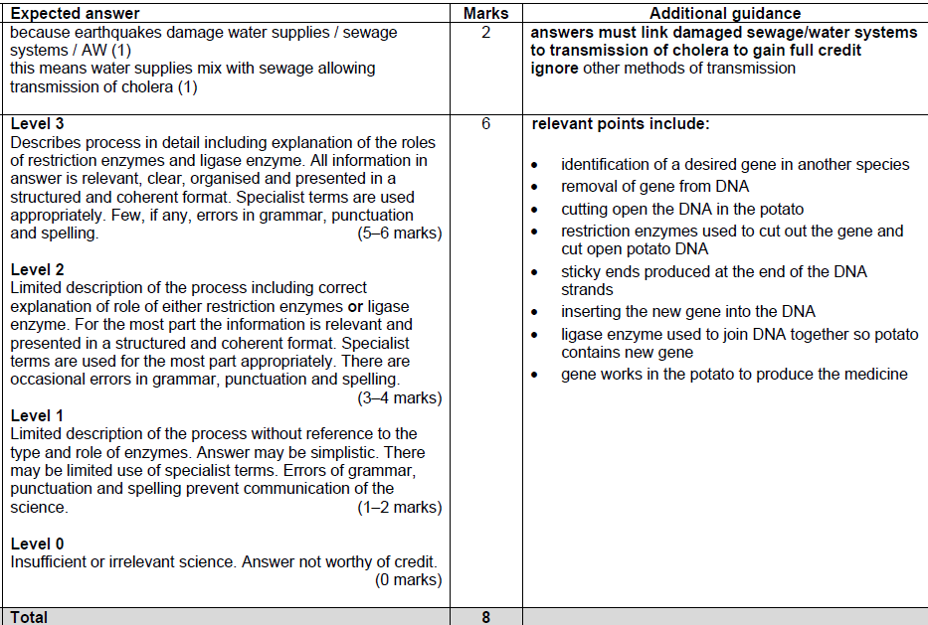

NC
Explain how this plant has become wilted. Use ideas about osmosis.

In this question you will be assessed on the quality of your English, the organisation of your ideas and your use of appropriate specialist vocabulary.

..................................................................................................................................................................................................................................................................................................................................................................................................................... .....................................................................................................................................................................................................................................................................................................................................................................................................................
.....................................................................................................................................................................................................................................................................................................................................................................................................................
.......................................................................................................................................
(6 marks)

Mark Scheme:
0 marks: No relevant information.
1-2 marks: A brief description of osmosis or wilting as a lack of water.
3-4 marks: A description of how water molecules move through the membrane of plant cells and explanation of wilting in terms of turgor pressure. The answer has a logical structure and spelling, grammar and punctuation are mostly correct.

5-6 marks: A clear and detailed explanation of how water molecule move through the membrane of plant cells, and the affect on the plant cell structure. The answer has a logical structure and uses correct spelling, grammar and punctuation.

Here are some points your answer may include:
- Water moves in and out of plant cells by osmosis through the cells membrane.
- Lack of water can cause plants to wilt.

- Water moves across a partially-permeable membrane from an area of high water concentration to an area of low water concentration.
- The membrane is partially permeable as water is small enough to pass through the pores, however, larger molecules such as sugar are too big to pass through the pores in the membrane.
- Water/turgor pressure in the cells supports the plants structure, lack of turgor pressure results in wilting.

- Movement of water across the membrane occurs due to the random movement of water particles.
- In a wilted plant water has moved from a high concentration in the plant cells to a lower concentration by random movement. This has resulted in a lack of turgor pressure in the cell. The cell is referred to as being flaccid. Eventually the cell contents will collapse away from the cell wall, referred to as a plasmolysed cell.

