Physics
6 mark
Questions

Describe how optical fibres are used to transmit digital light signals. Explain the advantages of sending information using digital signals transmitted by optical fibres.
In this question you will be assessed on the quality of your English, the organisation of your ideas and your use of appropriate specialist vocabulary.

..................................................................................................................................................................................................................................................................................................................................................................................................................... .....................................................................................................................................................................................................................................................................................................................................................................................................................
.....................................................................................................................................................................................................................................................................................................................................................................................................................
.......................................................................................................................................
(6 marks)

Mark Scheme:
Describe how optical fibres are used to transmit digital light signals. Explain the advantages of sending information using digital signals transmitted by optical fibres.
0 marks: No relevant information on the advantages of digital signals or optical fibres
1-2 marks: A brief description of how optical fibres transmit signals and of the advantages of digital signals or optical fibres.
3-4 marks: there is some description of how optical fibres transmit signals and of the advantages of digital signals and optical fibres. The answer has a logical structure and spelling, grammar and punctuation are mostly correct.
5-6 marks: There is clear and detailed description of how optical fibres transmit signals and of the advantages of both digital signals and optical fibres. The answer has a logical structure and uses correct spelling, grammar and punctuation.
Here are some points your answer may include:
Optical fibres work by bouncing waves off the sides of a very narrow core which is protected by outer layers.
The light signal enters the fibre so that it hits the boundary between the core and outer cladding at an angle greater than the critical angle for the material.
This causes total internal reflection of the light ray within the core.
The light signal enters at one end and is reflected again and again until it emerges at the other end.
Optical fibres can transmit data over long distances.
Transmitting data through optical fibres is very fast.
Digital signals don’t suffer from interference.
Multiplexing – you can transmit several signals at once in the same optical fibre.
Noise can be easily removed from digital signals.

CGP
Describe the laser light and explain how a laser is used in a CD player.
In this question you will be assessed on the quality of your English, the organisation of your ideas and your use of appropriate specialist vocabulary.

..................................................................................................................................................................................................................................................................................................................................................................................................................... .....................................................................................................................................................................................................................................................................................................................................................................................................................
.....................................................................................................................................................................................................................................................................................................................................................................................................................
.......................................................................................................................................
(6 marks)

Mark Scheme:
Describe the laser light and explain how a laser is used in a CD player.
0 marks: No relevant information on lasers or their use in CD players.
1-2 marks: There is a brief description of what a laser is.
3-4 marks: There is some description of what a laser is and how they are used in CD players. The answer has a logical structure and spelling, grammar and punctuation are mostly correct.
5-6 marks: There is a clear and detailed description of lasers and the way in which they are used in CD players. The answer has a logical structure and uses correct spelling, grammar and punctuation.
Here are some points your answer may include:
Lasers are narrow beams of visible light.
Laser light is monochromatic – all the waves in a laser beam are at the same frequency (and wavelength).
Light waves in a laser are all in phase with each other. This produces an intense beam.
The light waves in a laser are coherent.
Lasers have low divergence – the beam is narrow, and it stays narrow, even at a long distance from the light source (it doesn’t diverge).
The surface of a CD has a pattern of billions of shallow pits cut into it. The areas between the pits are called lands.
A laser shone onto the CD is reflected from the shiny bottom surface as it spins around in the CD player.
The beam is reflected from a land and a pit differently – and this difference can be picked up by a light sensor.
These differences in the reflected signals can then be changed into an electrical signal.

Jun 2012 B1C1P1 - Foundation
Mark Scheme:
Jun 2012 B1C1P1 – Higher

Mark Scheme:

Mark Scheme:

B1C1P1 Specimen - F

Energy losses in the home can be reduced by energy saving measures.
One measure is to put foam covered with shiny foil as insulation in the cavity.

Describe how energy is lost through the wall from the inside to the outside and how the insulation reduces the different types of energy loss.
 The quality of written communication will be assessed in your answer to this question.
............................................................................................................................................................
............................................................................................................................................................
............................................................................................................................................................
............................................................................................................................................................
............................................................................................................................................................
............................................................................................................................................................
............................................................................................................................................................
............................................................................................................................................................
....................................................................................................................................................... [6]
[Total: 6]

Mark Scheme:
Level 3  A detailed description of the three processes by which energy is transferred from inside to outside and how energy losses are reduced using cavity wall insulation. Applies knowledge of how inclusion of shiny foil reduces energy loss in the context of a cavity wall. All information in answer is relevant, clear, organised and presented in a structured and coherent format. Specialist terms are used appropriately. Few, if any, errors in grammar, punctuation and spelling.  (5-6 marks)  Level 2  Limited description of some processes by which energy is transferred, order from inside to outside may be confused, some reductions by cavity walls described but not linked to different forms of transfer. For the most part the information is relevant and presented in a structured and coherent format. Specialist terms are used for the most part appropriately. There are occasional errors in grammar, punctuation and spelling.  (3-4 marks)  Level 1  An incomplete description, naming some processes by which energy is transferred. Answer may be simplistic. There may be limited use of specialist terms. Errors of grammar, punctuation and spelling prevent communication of the science.  (1-2 marks)  Level 0  Insufficient or irrelevant science. Answer not worthy of credit.  (0 marks) | 6 | relevant points include:  cavity wall insulation slows down the process of heat transfer  cavity wall insulation retains more heat inside the home  energy moves by conduction through the internal bricks  foam or air is a poor conductor/foam or air is a good insulator so energy transfer is reduced  air / bubbles trapped (in foam) reduces convection  reduces heat or energy radiated into cavity  inner silver foil surface reflects heat or IR back  outer silver foil surface emits less heat  energy moves by conduction through the external bricks  accept cavity wall insulation reduces energy losses mainly by conduction and convection  ignore heat escapes  reject heat particles

B1C1P1 Specimen – H

Energy losses in the home can be reduced by energy saving measures.
One measure is to put foam covered with shiny foil as insulation in the cavity.
Describe how energy is lost through the wall from the inside to the outside and how the insulation reduces the different types of energy loss.
 The quality of written communication will be assessed in your answer to this question.
............................................................................................................................................................
............................................................................................................................................................
............................................................................................................................................................
............................................................................................................................................................
............................................................................................................................................................
............................................................................................................................................................
............................................................................................................................................................
............................................................................................................................................................
....................................................................................................................................................... [6]
[Total: 6]

Mark Scheme:
Level 3  A detailed description of the three processes by which energy is transferred from inside to outside and how energy losses are reduced using cavity wall insulation. Applies knowledge of how inclusion of shiny foil reduces energy loss in the context of a cavity wall. All information in answer is relevant, clear, organised and presented in a structured and coherent format. Specialist terms are used appropriately. Few, if any, errors in grammar, punctuation and spelling.  (5-6 marks)  Level 2  Limited description of some processes by which energy is transferred, order from inside to outside may be confused, some reductions by cavity walls described but not linked to different forms of transfer. For the most part the information is relevant and presented in a structured and coherent format. Specialist terms are used for the most part appropriately. There are occasional errors in grammar, punctuation and spelling.  (3-4 marks)  Level 1  An incomplete description, naming some processes by which energy is transferred. Answer may be simplistic. There may be limited use of specialist terms. Errors of grammar, punctuation and spelling prevent communication of the science.  (1-2 marks)  Level 0  Insufficient or irrelevant science. Answer not worthy of credit.  (0 marks) | 6 | relevant points include:  - cavity wall insulation slows down the process of heat transfer  - cavity wall insulation retains more heat inside the home  - energy moves by conduction through the internal blocks  - foam or air is a poor conductor / foam or air is a good insulator so energy transfer is reduced  - air/bubbles trapped (in foam) reduces convection  - reduces heat or energy radiated into cavity  - inner silver foil surface reflects heat or IR back  - outer silver foil surface emits less heat  - energy moves by conduction through the external bricks  accept cavity wall insulation reduces energy losses mainly by conduction and convection  ignore heat escapes  reject heat particles

B1C1P1 Jan 2012 – H

Mark Scheme:

B1C1P1 Jan 2012 – H

Mark Scheme:

P1P2P3 Jan 2012 – F

Mark Scheme
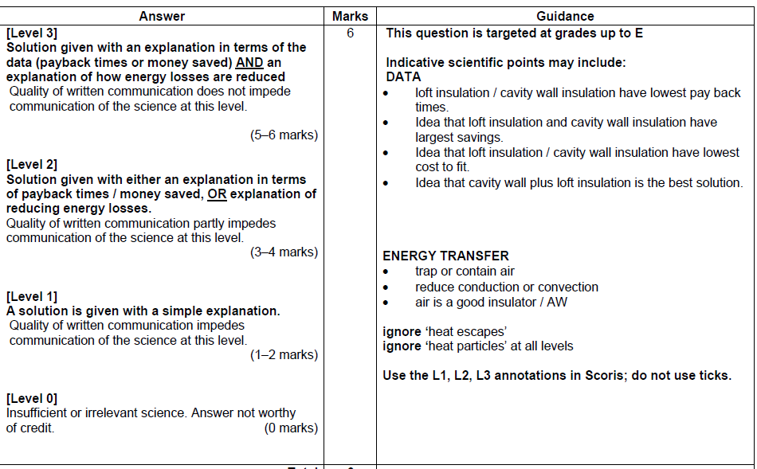

P1P2P3 Jan 2012 – H

Mark Scheme
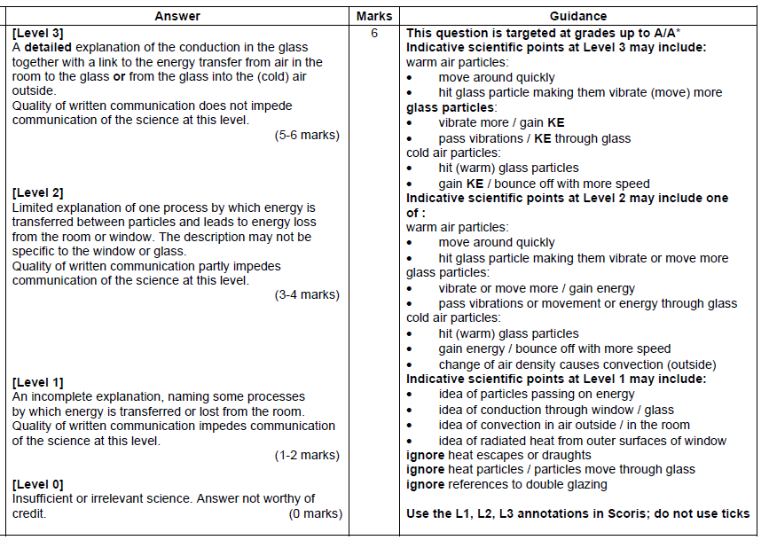

Jun 2012 B2C2P2 – Foundation

Mark Scheme:
Jun 2012 B2C2P2 – Higher
Mark Scheme:
Jun 2012 P1P2P3 – Foundation

Mark Scheme:
Jun 2012 P1P2P3 – Higher

Mark Scheme:
B2C2P2 Specimen – F

Mark Scheme

B2C2P2 Specimen – H

Mark Scheme:

P1P2P3 Jan 2012 – F

Mark Scheme
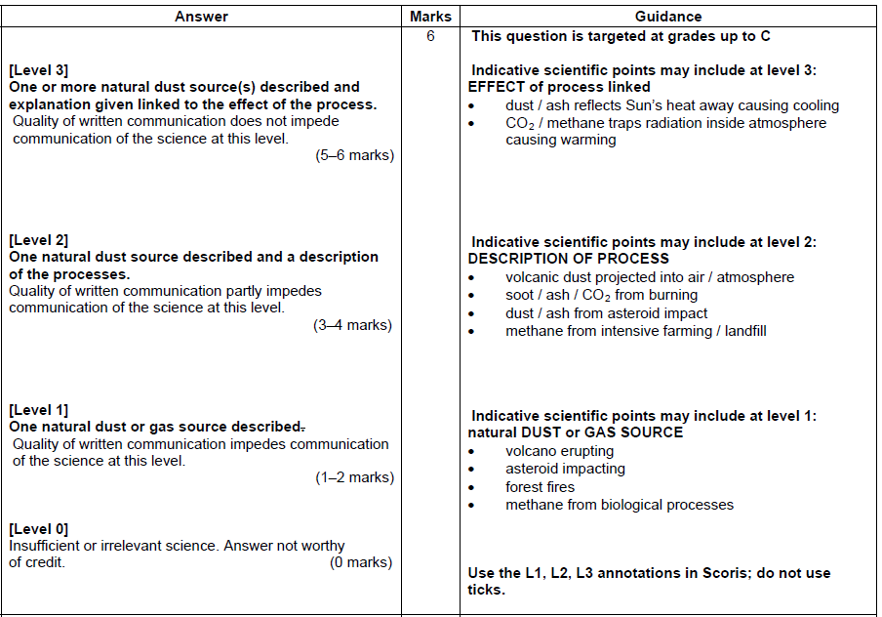

P1P2P3 Jan 2012 – H

Mark Scheme
CGP
A free- fall skydiver jumps from an aeroplane and his motion is recorded.
After his jump he looks at this velocity time graph of his fall.
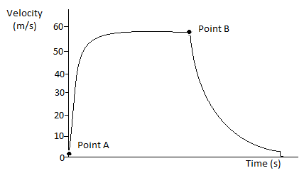
Describe the motion of the skydiver from point A to point B on the graph, in terms of the forces acting on him.
In this question you will be assessed on the quality of your English, the organisation of your ideas and your use of appropriate specialist vocabulary.
..................................................................................................................................................................................................................................................................................................................................................................................................................... .....................................................................................................................................................................................................................................................................................................................................................................................................................
.....................................................................................................................................................................................................................................................................................................................................................................................................................
.......................................................................................................................................
(6 marks)
Mark scheme:
A free- fall skydiver jumps from an aeroplane and his motion is recorded.
After his jump he looks at this velocity time graph of his fall.
Describe the motion of the skydiver from point A to point B on the graph, in terms of the forces acting on him.
0 marks: No relevant information on the skydiver’s motion.
1-2 marks: There is a brief description of the skydiver’s motion.
3-4 marks: There is some description of the skydiver’s motion, with brief reference to the forces acting on him. The answer has a logical structure and spelling, grammar and punctuation are mostly correct.
5-6 marks: There is clear and detailed description of the skydiver’s motion, including details of the forces acting on him. The answer has a logical structure and uses correct spelling, grammar and punctuation.
Here are some points your answer may include:
At first, the slope if the graph is steep because he is accelerating as the force of gravity acting on him is much more than the frictional force slowing him down.
As his speed increases the friction builds up, so his acceleration is gradually reduced – shown on the graph by the gradient of the slope decreasing.
Eventually the frictional force is equal to the accelerating force and the skydiver no longer accelerates and travels at a constant velocity.
The constant velocity is shown by the flat line on the graph.
The shows that the skydiver has reached his terminal velocity.

CGP
A vehicle’s stopping distance is dependent on the time it takes the driver to react and how long it takes the vehicle to come to a stop once the driver has applied the brakes. Read the driving advice below.
Explain how following each piece of advice would affect your stopping distance and improve road safety.
- Don’t drive if you are tired or under the influence of drugs or alcohol.
- Avoid distraction like mobile phones or loud music while driving.
- Don’t drive too close to the vehicle in front.
- Don’t break the speed limit.
- Reduce your speed and drive more cautiously if the road surface is wet, icy or slippery.

In this question you will be assessed on the quality of your English, the organisation of your ideas and your use of appropriate specialist vocabulary.

..................................................................................................................................................................................................................................................................................................................................................................................................................... .....................................................................................................................................................................................................................................................................................................................................................................................................................
.....................................................................................................................................................................................................................................................................................................................................................................................................................
.......................................................................................................................................
(6 marks)
Mark Scheme:
A vehicle’s stopping distance is dependent on the time it takes the driver to react and how long it takes the vehicle to come to a stop once the driver has applied the brakes. Read the driving advice below.
Explain how following each piece of advice would affect your stopping distance and improve road safety.
- Don’t drive if you are tired or under the influence of drugs or alcohol.
- Avoid distraction like mobile phones or loud music while driving.
- Don’t drive too close to the vehicle in front.
- Don’t break the speed limit.
- Reduce your speed and drive more cautiously if the road surface is wet, icy or slippery.

0 marks: No relevant information on stopping distance or road safety.
1-2 marks: there is a brief description of how at least one piece of the advice would affect stopping distances and improve road safety.
3-4 marks: There is some description of how at least three pieces of the advice would affect stopping distances and improve road safety. The answer has a logical structure and spelling, grammar and punctuation are mostly correct.
5-6 marks: There is a clear and detailed description of how the advice would affect stopping distances and improve road safety. The answer has a logical structure and uses correct spelling, grammar and punctuation.
Here are some points your answer may include:
Driving while tired, distracted or under the influence of drugs or alcohol increases your thinking time/distance. This increases your stopping distance.
Driving close to the vehicle in front means that you won’t have the required stopping distance if the car in front brakes suddenly. This means you are more likely to have a collision.
Driving too fast increases both your thinking distance and braking distance. Therefore it increases your overall stopping distance.
On slippery surfaces there is less friction to slow your vehicle down, so your braking distance will be further. Driving more slowly compensates for this because it reduced the thinking and braking distances. Therefore the overall stopping distance is shorter.
A shorter stopping distance means improved road safety because you are more likely to be able to stop in time to avoid a collision once you notice a hazard.

Jun 2012 B3C3P3 – Foundation

Mark Scheme:

Jun 2012 B3C3P3 – Higher

Mark Scheme:

Jun 2012 P1P2P3 – Foundation

Mark Scheme:

Jun 2012 P1P2P3 – Higher

Mark Scheme:

B3C3P3 Specimen – F

Mark Scheme:
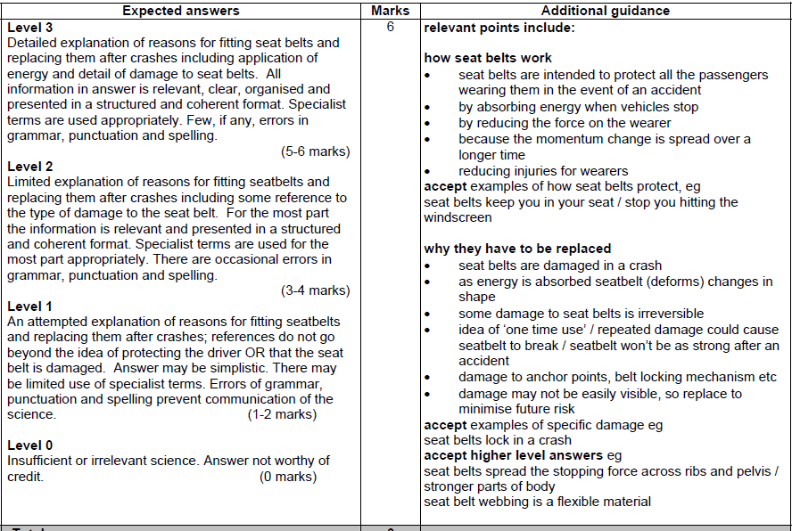

B3C3P3 Specimen – H

Mark Scheme:

P1P2P3 Jan 2012 – F

Mark Scheme
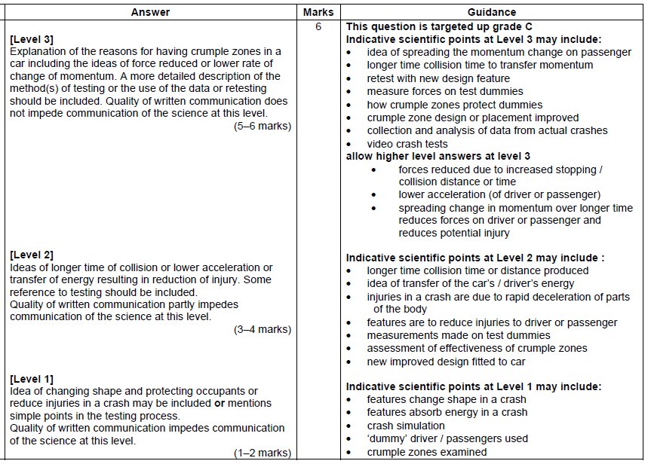

P1P2P3 Jan 2012 – H

Mark Scheme

CGP
The diagram on the left shows air through which a sound wave is passing. The diagram on the right shows a display of a light wave.
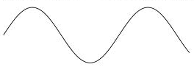
Describe and compare the features of sound and light waves. Include references to particle movement, wavelength, frequency and amplitude in your answer.
In this question you will be assessed on the quality of your English, the organisation of your ideas and your use of appropriate specialist vocabulary.

..................................................................................................................................................................................................................................................................................................................................................................................................................... .....................................................................................................................................................................................................................................................................................................................................................................................................................
.....................................................................................................................................................................................................................................................................................................................................................................................................................
.......................................................................................................................................
(6 marks)

Mark Scheme:
The diagram on the left shows air through which a sound wave is passing. The diagram on the right shows a display of a light wave.
Describe and compare the features of sound and light waves. Include references to particle movement, wavelength, frequency and amplitude in your answer.
0 marks: No description or comparison made.
1-2 marks: Description and comparison of at least one feature of sound and light waves.
3-4 marks: Description and comparison of at least three features of sound and light waves. The answer has a logical structure and spelling, grammar and punctuation are mostly correct.
5-6 marks: Answer gives a description and comparison of at least five features of sound and light waves. The answer has a logical structure and uses correct spelling, grammar and punctuation.
Here are some points your answer may include:
Sound waves are longitudinal waves. In longitudinal, the vibrations of the particles are along the same direction as the wave is travelling.
Light waves are transverse waves. In transverse waves the vibrations are at 90º to the direction of the travel of the waves.
Longitudinal sound waves have compressions and rarefactions, whereas transverse light waves have crests and troughs.
In longitudinal sound waves, compressions are where the particles are squashed together and rarefactions are where the particles are stretched out.
The wavelength is full cycle of a wave. For longitudinal sound waves this is from compression to compression or rarefaction. For transverse light waves this is from trough to trough or crest to crest.
For both longitudinal and transverse waves, frequency is how many complete waves there are per second passing a certain point.
The amplitude of a transverse light wave is the distance from the midline t the crest, or the midline to the trough. For longitudinal sound waves it’s either the midline to the compression or the midline to the rarefaction.

CGP
Evaluate the advantages and disadvantages of nuclear fusion over nuclear fission as a method of generating electricity.
In this question you will be assessed on the quality of your English, the organisation of your ideas and your use of appropriate specialist vocabulary.

..................................................................................................................................................................................................................................................................................................................................................................................................................... .....................................................................................................................................................................................................................................................................................................................................................................................................................
.....................................................................................................................................................................................................................................................................................................................................................................................................................
.......................................................................................................................................
(6 marks)

Mark Scheme:
Evaluate the advantages and disadvantages of nuclear fusion over nuclear fission as a method of generating electricity.
0 marks: No advantages and disadvantages given.
1-2 marks: There is a brief description of one advantage and one disadvantage.
3-4 marks: At least two advantages and two disadvantages are given. The answer has a logical structure and spelling, grammar and punctuation are mostly correct.
5-6 marks: Answer gives at least three advantages and three disadvantages. The answer has a logical structure and uses correct spelling, grammar and punctuation.
Here are some points your answer may include:
Advantages:
Much more energy is released by nuclear fusion than by nuclear fission for an equivalent mass of starting material.
Nuclear fusion does not produce radioactive waste.
There’s no risk of nuclear fallout with nuclear fusion.
Hydrogen can be used as fuel for nuclear fusion – so there’s no problem of fuel shortage.
Disadvantages:
Scientists have not yet found a way of getting more energy out of nuclear fusion reactors than they put in.
Nuclear fusion can only happen at very high temperatures and pressures which are hard to control safely.
Fusion reactors are hard to build as no material can withstand the high temperatures and pressures required.

B4C4P4 Specimen – F

Mark Scheme

B4C4P4 Specimen – H
Mark Scheme:
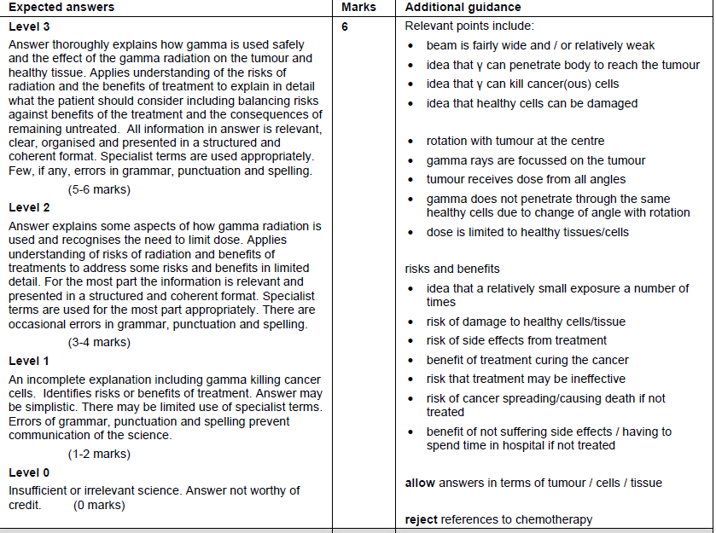

P4 DD
P4 Nuclear power stations use uranium as fuel to produce heat energy that can then be used to generate electricity. Energy is released from the uranium by something called a chain reaction.

Explain what is meant by a chain reaction
Explain how scientists stop nuclear reactions going out of control

In this question you will be assessed on the quality of your English, the organisation of your ideas and your use of appropriate specialist vocabulary.

..................................................................................................................................................................................................................................................................................................................................................................................................................... .....................................................................................................................................................................................................................................................................................................................................................................................................................
.....................................................................................................................................................................................................................................................................................................................................................................................................................
.......................................................................................................................................
(6 marks)
Mark Scheme:
P4 Nuclear power stations use uranium as fuel to produce heat energy that can then be used to generate electricity. Energy is released from the uranium by something called a chain reaction.

Explain what is meant by a chain reaction
Explain how scientists stop nuclear reactions going out of control

0 marks: No description given on chain reaction or control of chain reaction.
1-2 marks: one or two points included from the list below.
3-4 marks: Three to four points included from the list below. There must be mention of the chain reaction and a reference to how it can be controlled. The answer has a logical structure and spelling, grammar and punctuation are mostly correct.
5-6 marks: Answer clearly gives a detailed description of the chain reaction and how control rods are used to absorb some of the neutrons. The answer has a logical structure and uses correct spelling, grammar and punctuation.

Here are some points your answer may include:
Explain what is meant by a chain reaction

- uranium nucleus hit by neutron
- causes nucleus to split
- energy released
- more neutrons released.
- these neutrons can cause further uranium nuclei to split.

Explain how scientists stop nuclear reactions going out of control

- control rods placed in the reactor
- to absorb some of the neutrons
- allowing enough neutrons to remain to keep the process operating.

P4 DD
Explain how radioactive sources are used in medicine (a) to treat cancer and (b) as a tracer

In this question you will be assessed on the quality of your English, the organisation of your ideas and your use of appropriate specialist vocabulary.

..................................................................................................................................................................................................................................................................................................................................................................................................................... .....................................................................................................................................................................................................................................................................................................................................................................................................................
.....................................................................................................................................................................................................................................................................................................................................................................................................................
.......................................................................................................................................
(6 marks)

P4 - Explain how radioactive sources are used in medicine (a) to treat cancer and (b) as a tracer

Mark Scheme:
0 marks: No points mentioned regarding how radiation is used as a tracer or as a cancer treatment.
1-2 marks: Mention that gamma rays are used to treat cancer and beta or gamma used as a tracer.
3-4 marks: At least two points mentioned about how gamma rays are used in cancer treatment and two points for how gamma/beta radiation is used as a tracer. The answer has a logical structure and spelling, grammar and punctuation are mostly correct.
5-6 marks: At least three points mentioned about how gamma rays are used in cancer treatment and three points for how gamma/beta radiation is used as a tracer. The answer has a logical structure and uses correct spelling, grammar and punctuation.

Here are some points your answer may include:
To treat cancer
- gamma rays
- focused on tumour
- wide beam used
- rotated round the patient with tumour at centre
- which limits damage to non-cancerous tissue.

As a tracer
- beta or gamma emitter
- with a short half life
- drunk/eaten/ingested/injected into the body
- allowed to spread through the body
- followed on the outside by a radiation detector.

CGP
In the 17th Century, there were two theories to explain the nature of light – Isaac Newton’s particle theory and Christian Huygens’s wave theory.
Describe what Young’s double slit experiment showed and how it helped shift scientific opinion away from the particle theory of light and towards the wave theory.
In this question you will be assessed on the quality of your English, the organisation of your ideas and your use of appropriate specialist vocabulary.

..................................................................................................................................................................................................................................................................................................................................................................................................................... .....................................................................................................................................................................................................................................................................................................................................................................................................................
.....................................................................................................................................................................................................................................................................................................................................................................................................................
.......................................................................................................................................
(6 marks)

Mark Scheme:
In the 17th Century, there were two theories to explain the nature of light – Isaac Newton’s particle theory and Christian Huygens’s wave theory.
Describe what Young’s double slit experiment showed and how it helped shift scientific opinion away from the particle theory of light and towards the wave theory.
0 marks: There is no relevant information on Young’s double-slit experiment or the shift in scientific opinion from the particle theory to the wave theory of light.
1-2 marks: There is a brief description of Young’s double-slit experiment or the shift in scientific opinion from the particle theory to the wave theory of light.
3-4 marks: There is some description of Young’s double-slit experiment and the shift in scientific opinion from the particle theory to the wave theory of light. The answer has a logical structure and spelling, grammar and punctuation are mostly correct.
5-6 marks: There is a clear and detailed description of Young’s double-slit experiment and the shift in scientific opinion from the particle theory to the wave theory of light. The answer has a logical structure and uses correct spelling, grammar and punctuation.
Here are some points your answer may include:
- Young’s double-slit experiment shines coherent light through two narrow slits on to a screen.
- Light travelling through each slit is diffracted.
- The light waves interfere, producing an interference pattern on the screen of light and dark fringes.
- Particles cannot interfere or diffract, so Young’s double-slit experiment shows light acting as a wave. This evidence helped to cause scientific opinion to shift away from particle theory.

P4P5P6 specimen – Higher

Mark Scheme:
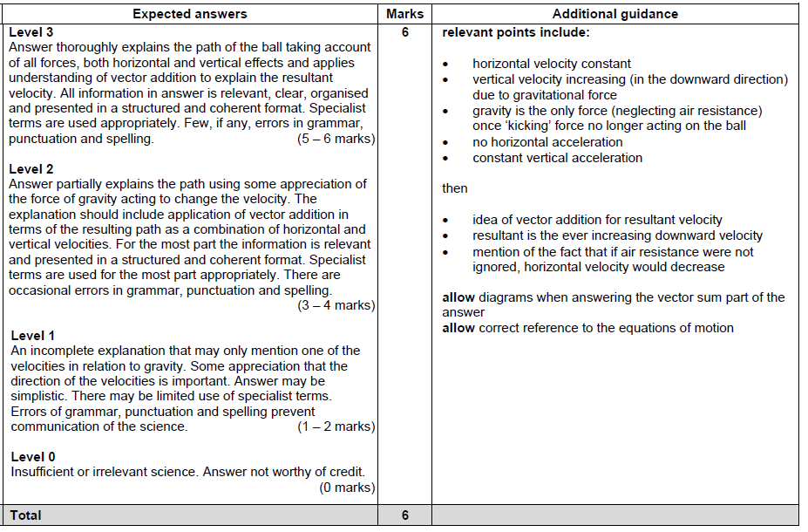

CGP
Dan’s kitchen has an extractor fan that runs a powerful motor in a high-current, high-voltage circuit. The fan is operated using a relay switch, shown below:
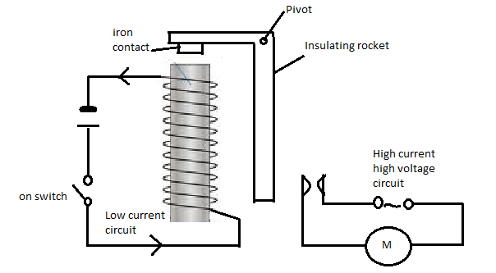
Describe how Dan turning on the switch in the low-current circuit turns on the fan motor. Explain why a relay switch is used to turn on the fan.
In this question you will be assessed on the quality of your English, the organisation of your ideas and your use of appropriate specialist vocabulary.
..................................................................................................................................................................................................................................................................................................................................................................................................................... .....................................................................................................................................................................................................................................................................................................................................................................................................................
.....................................................................................................................................................................................................................................................................................................................................................................................................................
.......................................................................................................................(6 marks)
Mark scheme:
Dan’s kitchen has an extractor fan that runs a powerful motor in a high-current, high-voltage circuit. The fan is operated using a relay switch, shown below:
Describe how Dan turning on the switch in the low-current circuit turns on the fan motor. Explain why a relay switch is used to turn on the fan.
0 marks: There is no relevant information on how the relay switch works.
1-2 marks: There is a brief description of how the relay switch works.
3-4 marks: There is some description of how the relay switch works and why it is needed. The answer has a logical structure and spelling, grammar and punctuation are mostly correct.
5-6 marks: There is a clear and detailed description of how the relay switch works and why it is needed. The answer has a logical structure and uses correct spelling, grammar and punctuation.
Here are some points your answer may include:
- When Dan closes the switch in the low-current circuit, it turns on the electromagnet.
- The electromagnet attracts the iron contact on the rocker.
- The rocker pivots and closes the contacts in the high-current circuit.
- When the contacts in the high-current circuit are closed current flows through the circuit and powers the extractor fan.
- The relay is used because it makes it safe to use the extractor fan. If there is a fault, Dan is isolated from the high voltage circuit and will only be in contact with the low current/voltage circuit

CGP
Scientific developments mean that computers are becoming increasingly miniaturised while becoming more powerful and widely available.
Discuss the benefits and drawbacks of increased miniaturisation.
In this question you will be assessed on the quality of your English, the organisation of your ideas and your use of appropriate specialist vocabulary.

..................................................................................................................................................................................................................................................................................................................................................................................................................... .....................................................................................................................................................................................................................................................................................................................................................................................................................
.....................................................................................................................................................................................................................................................................................................................................................................................................................
.......................................................................................................................................
(6 marks)

Mark Scheme:
Scientific developments mean that computers are becoming increasingly miniaturised while becoming more powerful and widely available.
Discuss the benefits and drawbacks of increased miniaturisation.
0 marks: There is no relevant information on the benefits or drawbacks of miniaturisation.
1-2 marks: There is a brief discussion, including one benefit and /or one drawback of miniaturisation.
3-4 marks: There is some discussion, including at least three benefits and drawbacks of miniaturisation. The answer has a logical structure and spelling, grammar and punctuation are mostly correct.
5-6 marks: There is a detailed discussion, including at least five benefits and drawbacks of miniaturisation. The answer has a logical structure and uses correct spelling, grammar and punctuation.
Here are some points your answer may include:
- Smaller devices use less raw materials.
- Most customers like smaller devices.
- Smaller electronic devices are more portable.
- More powerful and feature-filled devices can be produced.
- It can be more complex (and expensive) to produce small devices.
- Smaller devices are easier to lose.

P4P5P6 Specimen Higher

Mark Scheme
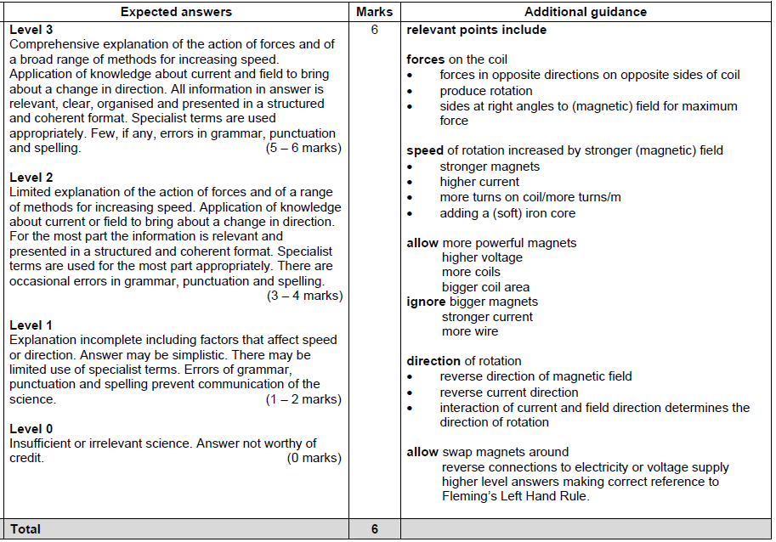

P4P5P6 specimen – Foundation

Mark Scheme:
