PiXL Gateway: Masterclass - Physics

Contents:
- Checklist of Skills and Basic Knowledge (page 3)

- Basic Physics Knowledge (page 4)
  - Force and Motion
  - DC Circuits
  - Waves
  - Knowledge Quick Check

- Basic Investigative Skills (page 7)
  - Collecting and Recording Data
  - Graphing
  - Types of Error
  - Finding the Gradient and Applying y = mx + c

- Basic Knowledge and Skills in Mathematics Required for Physics (page 10)
  - Significant Figures
  - Rearranging Equations
  - Trigonometry and Geometry
  - Units
- PiXL Independence Templates (page 13)

I . Checklist of Skills and Basic Knowledge
Basic Physics Knowledge
I can explain the effects of forces on objects
I can calculate acceleration
I can construct and use motion graphs to calculate acceleration
I can calculate displacement from a motion graph
I can define current, potential difference and resistance and perform calculations using Ohm’s Law
I can describe how to practically measure resistance
I can make predictions of values of current and potential difference in series and parallel circuits
I can label a wave and define the terms wavelength, amplitude and frequency
I can perform calculations with the wave equation
I can define the terms reflection and diffraction and explain the phenomenon of refraction
Basic Investigative Knowledge and Skills
I can construct a results table and collect results following scientific conventions
I can draw a graph following scientific conventions
I can calculate the gradient of a line of best fit and use a tangent to calculate the gradient of a curve
I can link the equation of a straight line (y = mx + c) to a physics equation and state what is represented by a graph’s gradient and y-intercept
Basic Maths Knowledge and Skills
I can identify the correct units in a calculation
I can convert and use standard form
I can give my answer to an appropriate number of significant figures
I can use a calculator to handle trigonometric functions (sin, cos, tan)
I can change the subject of an equation
I can use Pythagoras’s Theorem
I can calculate areas of triangles and circumferences and areas of circles

Presentation 1: Basic Physics Knowledge
A Level Physics builds on your GCSE knowledge. You will meet the following three topics again in Year 1 of the course, so it is essential you have the foundations in place.

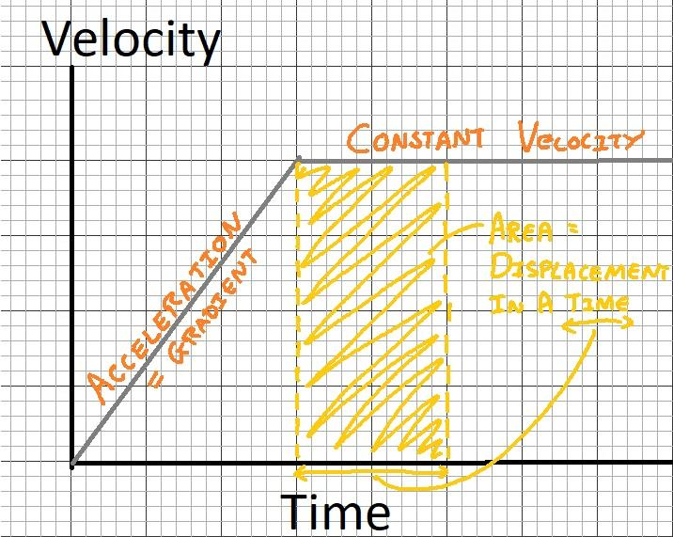
- Forces and Motion
If there is a resultant force on an object it will accelerate.
An acceleration is the rate change in velocity (remember velocity is a vector)
$a=\frac{(v-u)}{t}$
The larger the mass ‘m’ of an object, the larger the force ‘F’ that need to be applied to reach the same acceleration ‘a’.
$$F=ma$$
A velocity vs time graph can be used to calculate acceleration (using the gradient) or the displacement (the area under the line).
Going Deeper
The area under a velocity time motion graph can be used to derive another equation that links displacement ‘s’ with initial ‘u’ and final ‘v’ velocity and time ‘t’. See if you can work out the area only using these algebraic terms.

b. DC Electricity
Current ‘I’ is the rate of flow of charge ‘Q’ in a circuit. It is measured in Amps with an ammeter in series.
Potential difference ‘V’ is a measure of how much energy ‘E’ is transferred by the charge ‘Q’ as it passes through a component in the circuit. It is measured in Volts with a voltmeter in parallel.
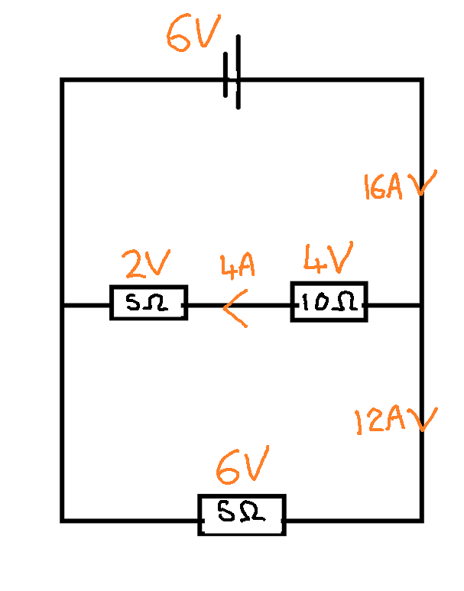
The resistance ‘R’ of a component is a measure of how difficult it is for the current to flow. It is measured in Ohms ‘Ω’. A high resistance lowers the current and components with a high resistance will take a larger share of energy in a loop of a circuit.
A series circuit is a single loop. The current is always the same at every point the loop. The energy is shared between all components so the potential difference across each individual component will match the supply voltage of the cell.
A parallel circuit contains multiple loops. The current splits at a junction but it always conserved (the amount flowing in equals the amount flowing out). More current flows down the path of least resistance. Each loop in the circuit gets its own supply of energy to be shared.
Going Deeper
In reality a cell has an ‘internal resistance’ which means that it also uses some of the energy supplied to the circuit when a current flows through it. This means that if a cell is a 1.5V cell as soon as a current flows through it cannot supply 1.5V to the circuit, this potential difference across the internal resistance inside the cell is referred to as “lost volts”. The larger the current the larger the “lost volts”.
c. Waves
Waves transfer energy without transferring matter. Light and sound are common examples of waves. A wave can be thought of a series of oscillations.
There are several wave features that you should be able to recall from GCSE Science:

- Wavelength - the distance between two identical points on the wave.
- Amplitude - the maximum displacement of the waves oscillation.
- Frequency - the number of oscillations per second, measured in Hertz.
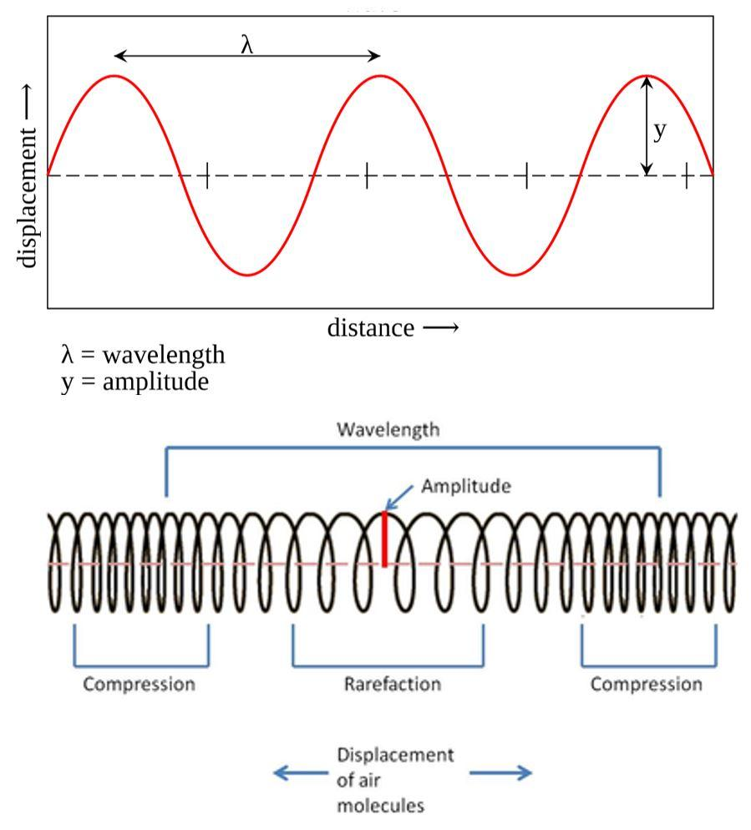
- Transverse waves - oscillate perpendicular to the plane of propagation.
- Longitudinal waves - oscillate in the same plane of propagation with areas of compression and rarefaction.
The wave equation links the wave speed, c, to its frequency, f, and wavelength, ƛ : $c=fλ$
Waves can be reflected - the wave hits a boundary between materials and it returns back into the same material.
Waves can be refracted - when it enters a new medium its direction can change. The wave speed and wavelength change but the frequency remain the same.
Waves can be diffracted - when a wave encounters an object that is of comparable size to its own wavelength the wave spreads out.
Going Deeper
Infrared waves were discovered by Herschel when he noticed that a thermometer placed just outside the visible spectrum recorded a greater temperature than thermometers within it. He used a prism from a chandelier in his home in Bath. Infrared light is just a lower frequency oscillation of the electromagnetic field that forms visible light.
d. TASK Quick Knowledge Quiz
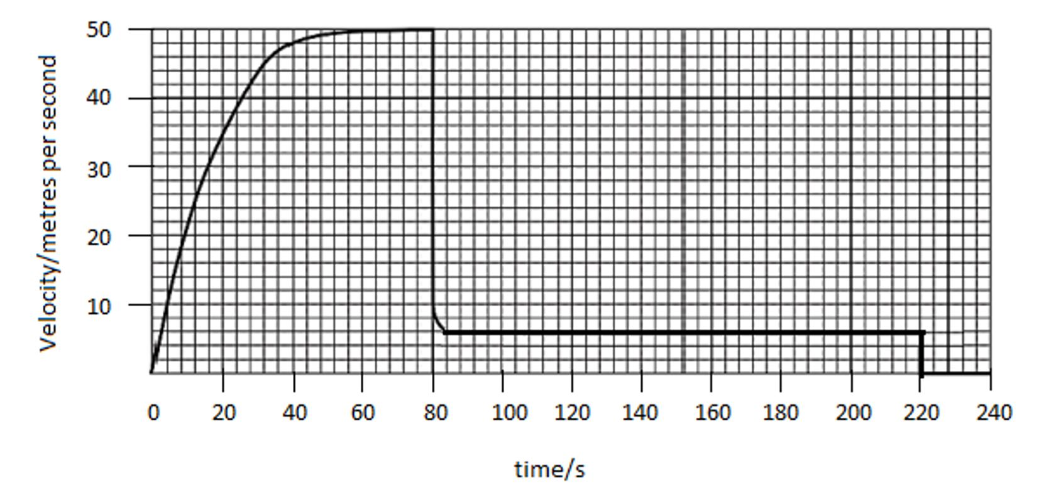
1)

- Explain the motion shown on the velocity time graph in terms of forces.
- Calculate the average acceleration in the first 80s.
- Estimate the distance travelled in the final 140s.
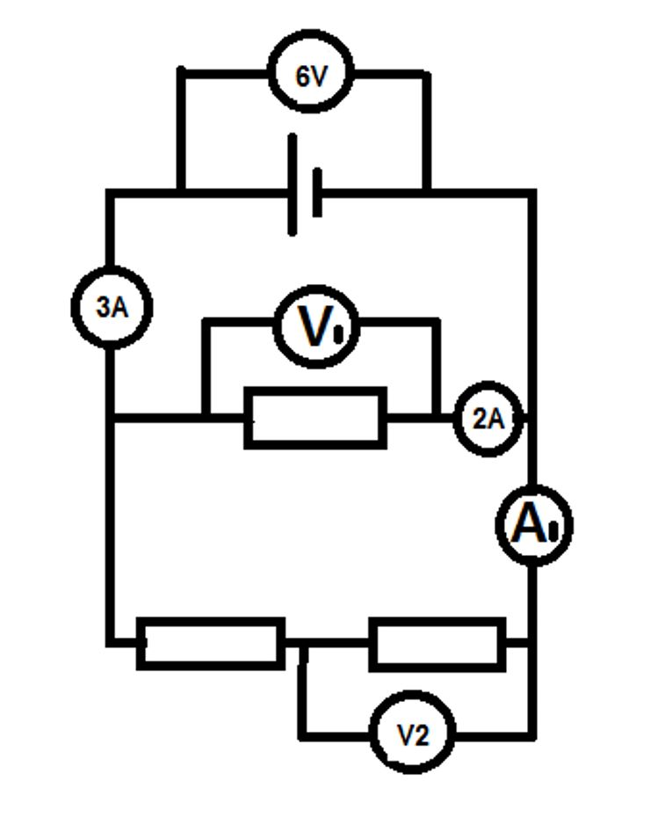
2)
- State the potential difference
  - V1 =
  - V2 =
- State the current A1 =
- Calculate the resistance of the resistors using Ohm’s Law.

3)

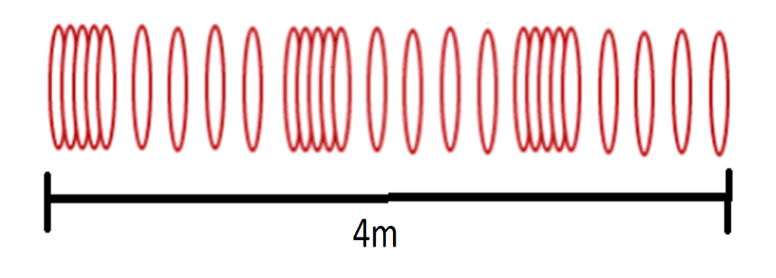

- Label and state the wavelength of the longitudinal slinky wave shown.
- Each loop on the slinky takes 0.5s to complete 1 oscillation. Calculate the frequency and wave speed of the wave.

Presentation 2: Basic Investigative Skills

- Collecting and Recording Data

Collecting and presenting data in a table is essential in a physics investigation to ensure that correct conclusions can be drawn.
Below is a set of rules to follow for the construction and completing of results tables:
- Tables should have clear headings with units indicated using a distinguishing mark before the unit, e.g. / or ()
- It is good practice to draw a table before an experiment commences and then enter data straight into the table.
  - This may mean that you record results in a non-ascending or descending order which is fine when working in a lab book.
  - If you were to present the table or to use it to identify patterns rewriting in ascending or descending order after the experiment would be helpful.
- The independent variable should be in the left hand column.
- The body of the table should not contain any units
- Data within a column should be recorded to the same number of decimal places which is determined by the resolution of the measuring instrument used.
- Any data which is a calculation from other data in the table should not be recorded to more significant figures.
Below is an example of how this should look in practise:
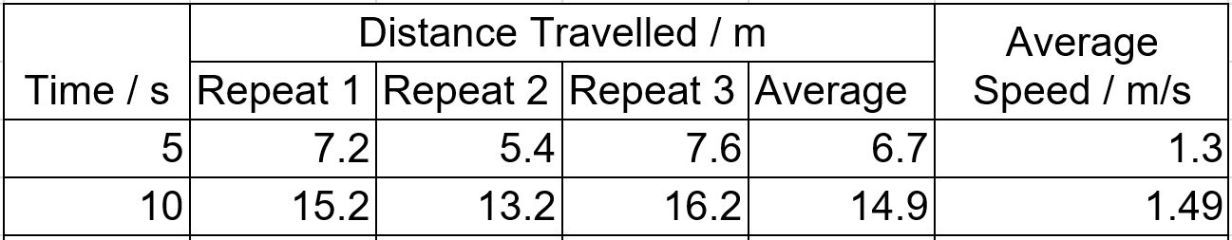
In A-Level Physics we combine uncertainties as they accumulate through the measurements made in an investigation. This allows our final result to be published with a value of confidence. It is unlikely you will be able to measure ‘g’ as 9.81 ms⁻² in your classroom but you should be able to measure it to that within your uncertainties e.g. 9.6 +/- 0.3 ms⁻² .
Going Deeper
The uncertainty in a measurement comes from the resolution of the measuring apparatus. For example, a standard ruler is able to measure the nearest 1mm. When recording results obtained using a ruler you should always record values to this level of precision e.g. 10.0cm NOT 10cm. The uncertainty is usually quoted as +/- the resolution of the instrument. e.g. 10.0 +/- 0.1mm.

TASK: Use the stopwatch on your phone to investigate the average time of an advert in a television break. You should record your values to a sensible number of significant figures and calculate and write down an average to an appropriate number of significant figures.

- Graphing
A graph is often an essential part of an investigation. Physicists use graphs of results to determine physical constants with greater accuracy and also to help identify trends in results.
You will be expected to produce graphs in your exams as well as in investigations in lessons. Below is a set of rules to follow when creating a graph:
- Axis should be labelled with a unit which is separated by a distinguishing mark, e.g. / or ()
- Data points should only by plotted using x or +.
- The plotted points should occupy as much of the graph paper as possible in both the x and y directions.
  - Use at least half of the graph paper in both the x and y direction
  - Use a sensible scale - multiples of 1,2,5,10,20,50 etc.
  - Axis do not have to start at (0,0) but be careful if you need to work out the y-intercept.
- A line of best fit should be drawn
  - Use a thin pencil line
  - Ignore anomalies and don’t force it through every plotted point
  - Have roughly the same number of points on either side
  - Not all line of best fits go through the origin (0,0) so don’t force it!
Going Deeper
Sometimes error bars are added to plots. Error bars show the uncertainty in a value and help you to decide the correct line of best fit or whether a result is anomalous.
An error bar should be a line that illustrates the range of uncertainty. The length of an error bar can be drawn as half the range of repeated values or the actual uncertainty in a measurement.

- Types of Error
There are two main types of error to be considered and evaluated in an investigation:
Random Errors
- Unpredictable and vary from measurement to measurement.
- Random errors are always present.
- They cause reading a to be spread about the true value.
- Their effects can be reduced by taking multiple repeated measurements and calculating a mean.
Systematic Errors
- A systematic error is the same for each measurement made.
- It occurs when there is a problem with the measuring instrument e.g. a zero error, or the observation technique e.g. reading the wrong scale, or a problem with the environment e.g. the experiment was not conducted at standard temperature and pressure. The whole experiment should be repeated using a different technique/instrument if a systematic error has occurred.

Finding the gradient and applying y = mx + c

The gradient ‘m’ of a line of best fit should always be found by drawing a large triangle which is over half the length of the line of best fit. (This helps to minimise uncertainties).
If the line of best fit is a curve, a tangent should be drawn. All workings and read-offs should be shown and the gradient ‘m’ can be calculated using:
$$m=\frac{Change in y}{Change in x}=\frac{Δy}{Δx}$$

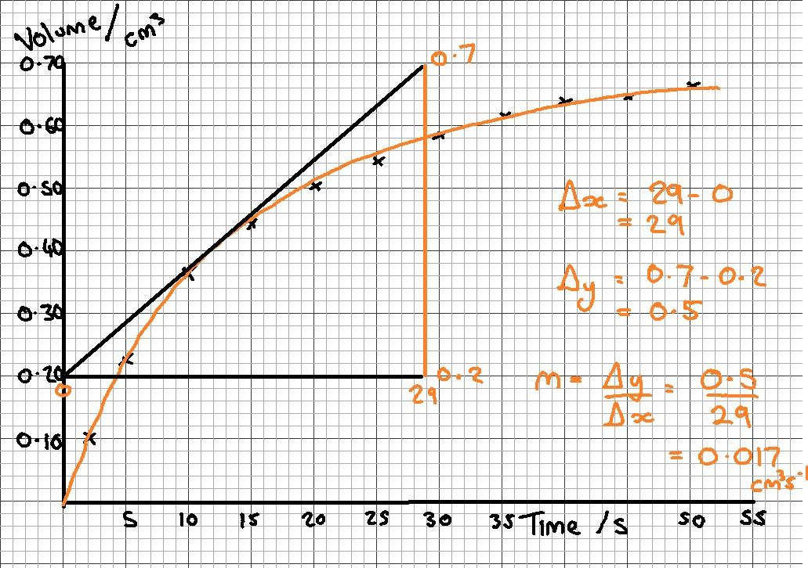

Gradients are often used to determine the value of physical constants from results. We can match the equation of a straight line y = mx + c to a physics equation. Here are two examples:
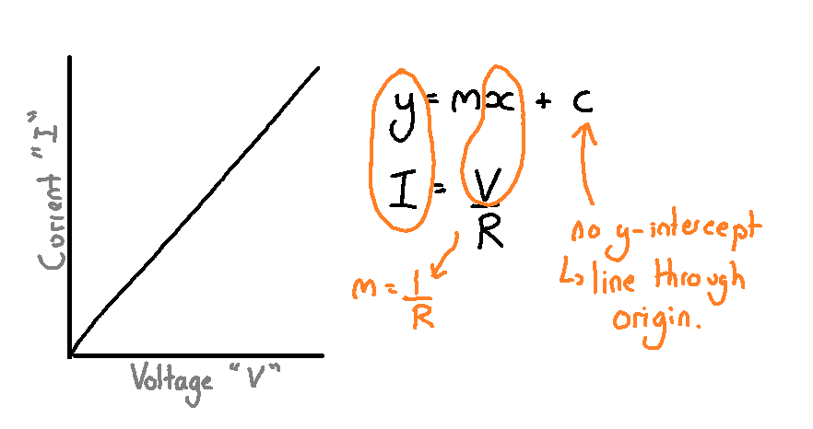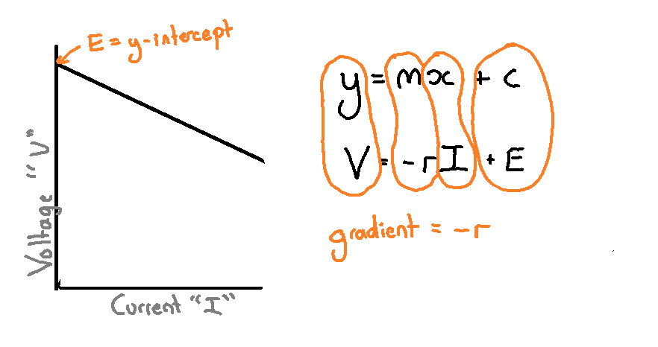

Presentation 3: Basic Skills and Knowledge in Mathematics Required for Physics

Prefixes
Below is a table of the prefixes you should know. You will have come across some of these at GCSE.

Prefix | Symbol | Power of ten
Pico | p | x 10⁻¹²
Nano | n | x 10⁻⁹
Micro | μ | x 10⁻⁶
Milli | m | x 10⁻³
Centi | c | x 10⁻²
Kilo | k | x 10³
Mega | M | x 10⁶
Giga | G | x 10⁹
Tera | T | x 10¹²

Significant figures
In a calculation answers should be given to the same number of significant figures as the question. When a question has a varying number of significant figures your answer should be quoted to the smallest number of significant figures used in the question. Avoid rounding too much until the very end of a question.

TASK: Round these to 3 significant figures:

- 34.798 b) 109.7 c) 0.9996 d) 0.005122

Rearranging equations
This is a skill that you will have practiced at GCSE in Physics and Mathematics.
You will come across trickier equations to rearrange at A level so ensure you understand the basic skills. You can take several approaches to rearrange, however a quick method is cross multiplication; if a quantity is a denominator, it becomes a numerator on the other side and vice versa.

Examples:$Speed = \frac{Distance}{Time}$ $Momentum = mass x velocity$
$Speed x Time = Distance$ $\frac{Momentum}{mass}=velocity$

TASK: Rearrange the following equation to find a) Force b) Area
$$Pressure = \frac{Force}{Area}$$

Trigonometry

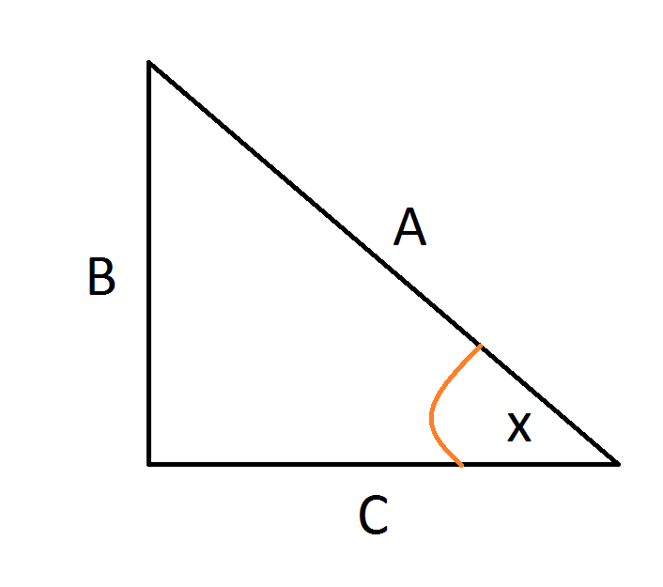
You need to be confident using Pythagoras’s Theorem and Trigonometry (SOHCAHTOA) in order to find lengths and angles.

To calculate the length ‘A’: A² = B² + C²
To calculate angle ‘x’ you could use any of these methods:
$sin x = \frac{B}{A}$ $cos x = \frac{C}{A}$ $tan x = \frac{B}{C}$

Geometry
You will need to be able to calculate the area of a triangle, rectangle and circle. The Physics equation sheet has the formula to calculate the area and circumference of a circle.

Triangles: area = 0.5 x base x perpendicular height
Rectangles: area = base x height
Circles: area = πr² circumference = 2π r

Units
The table below contains the quantities and units that you should ensure you are familiar with.
Quantity | Symbol | Unit
Velocity | v | ms⁻¹ (m/s)
Acceleration | a | ms⁻²
Time | t | s
Force | F | N
Resistance | R | Ω
Potential difference | V | V
Current | I | A
Energy | E or W | J
Pressure | P | Pa
Momentum | p | kgms⁻¹
Power | P | W
Density | ρ | kgm⁻³
Charge | Q | C

Below are the seven ‘base’ or S.I units. All other units can be derived from them. e.g. Charge: Charge = current(A) x time(s) so the S.I unit would be As (Ampere seconds). 1 As = 1C (Coulomb)

Quantity | Unit
electric current | A
temperature | K
time | s
length | m
mass | kg
luminous intensity | cd
amount of substance | mol

PiXL Independence: Ranking Triangle

Name of Topic: __________________________________________________________________________________________________

The most important information goes at the top and then the least important at the bottom. Make sure you justify WHY you think it the most/least important.

_______________________________________________________________________________________________________________________________________________________________________________________________________________________________________________________________________________________________________________________________________________________________________________________

PiXL Independence: ‘Boxing Up’ Activity

Name of Topic: __________________________________________________________________________________________________
Read the text and then put your thoughts in to different boxes so that you have ‘boxed up’ the text.

Box 1 – 3 things I did not know

Box 2 – 3 things I understand better now

Box 3 – 3 things I already knew

Reading List

- Surely You're Joking Mr Feynman: Adventures of a Curious Character
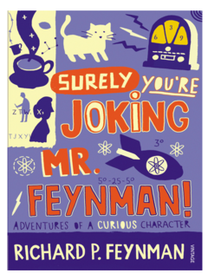
ISBN - 009917331X - Richard Feynman was a Nobel Prize winning Physicist. In my opinion he epitomises what a Physicist is. By reading this books you will get insight into his life’s work including the creation of the first atomic bomb and his bongo playing adventures and his work in the field of particle physics.
(Also available on Audio book). https://www.waterstones.com/books/search/term/surely+youre+joking+mr+feynman++adventures+of+a+curious+character

Moondust: In Search of the Men Who Fell to Earth

ISBN – 1408802384 - One of the greatest scientific achievements of all time was putting mankind on the surface of the moon. Only 12 men made the trip to the surface, at the time of writing the book only 9 are still with us. The book does an excellent job of using the personal accounts of the 9 remaining astronauts and many others involved in the space program at looking at the whole space-race era, with hopefully a new era of space flight about to begin as we push on to put mankind on Mars in the next couple of decades.

https://www.waterstones.com/books/search/term/moondust++in+search+of+the+men+who+fell+to+earth

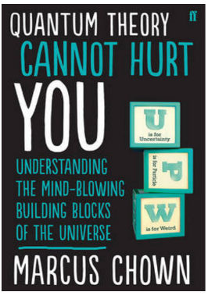
Quantum Theory Cannot Hurt You: Understanding the Mind-Blowing Building Blocks of the Universe

ISBN - 057131502X - Any Physics book by Marcus Chown is an excellent insight into some of the more exotic areas of Physics that require no prior knowledge. In your first year of A-Level study you will meet the quantum world for the first time. This book will fill you with interesting facts and handy analogies to whip out to impress your peers!

https://www.waterstones.com/book/quantum-theory-cannot-hurt-you/marcus-chown/9780571315024

A Short History of Nearly Everything

ISBN – 0552997048 - A modern classic. Popular science writing at its best. A Short History of Nearly Everything Bill Bryson’s quest to find out everything that has happened from the Big Bang to the rise of civilization - how we got from there, being nothing at all, to here, being us. Hopefully by reading it you will gain an awe-inspiring feeling of how everything in the universe is connected by some fundamental laws.

https://www.waterstones.com/books/search/term/a+short+history+of+nearly+everything

Thing Explainer: Complicated Stuff in Simple Words

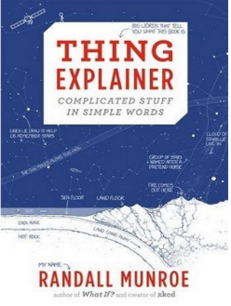
ISBN – 1408802384 - This final recommendation is a bit of a wild-card – a book of illustrated cartoon diagrams that should appeal to the scientific side of everyone. Written by the creator of online comic XTCD (a great source of science humour) is a book of blueprints from everyday objects such as a biro to the Saturn V rocket and an atom bomb, each one meticulously explained BUT only with the most common 1000 words in the English Language. This would be an excellent coffee table book in the home of every scientist.

https://www.waterstones.com/book/thing-explainer/randall-munroe/9781473620919

Watching List

Science Fictions Films

Moon (2009)

Gravity (2013)

Interstellar (2014)

The Imitation Game (2015)

The Prestige (2006)

Online Clips / Series

Minute Physics – Variety of Physics questions explained simply (in felt tip) in a couple of minutes. Addictive viewing that will have you watching clip after clip – a particular favourite of mine is “Why is the Sky Dark at Night?”

https://www.youtube.com/user/minutephysics

Wonders of the Universe / Wonders of the Solar System – Both available of Netflix as of 17/4/16 – Brian Cox explains the Cosmos using some excellent analogies and wonderful imagery.

Shock and Awe, The Story of Electricity – A 3 part BBC documentary that is essential viewing if you want to see how our lives have been transformed by the ideas of a few great scientists a little over 100 years ago. The link below takes you to a stream of all three parts joined together but it is best watched in hourly instalments. Don’t forget to boo when you see Edison. (alternatively watch any Horizon documentary – loads of choice on Netflix and the I-Player)

https://www.youtube.com/watch?v=Gtp51eZkwoI

NASA TV – Online coverage of launches, missions, testing and the ISS. Plenty of clips and links to explore to find out more about applications of Physics in Space technology.

http://www.nasa.gov/multimedia/nasatv/

The Fantastic Mr. Feynman – I recommended the book earlier, I also cannot recommend this 1 hour documentary highly enough. See the life’s work of the “great explainer”, a fantastic mind that created mischief in all areas of modern Physics.

https://www.youtube.com/watch?v=LyqleIxXTpw

© The PiXL Club Ltd. June 2018

This resource is strictly for the use of member schools for as long as they remain members of The PiXL Club. It may not be copied, sold, or transferred to a third party or used by the school after membership ceases. Until such time it may be freely used within the member school.
All opinions and contributions are those of the authors. The contents of this resource are not connected with, or endorsed by, any other company, organisation or institution.
PiXL Club Ltd endeavour to trace and contact copyright owners. If there are any inadvertent omissions or errors in the acknowledgements or usage, this is unintended and PiXL will remedy these on written notification.

