A Level Design and Technology – Product Design (Edexcel)

A Level Design and Technology equips you with design skills for the future – you’ll learn how to recognise design needs and develop an understanding of how current global issues, including integrating technology, impacts on today’s world. During the next two years, you’ll develop the confidence to innovate and produce creative design solutions as you develop your own design brief with a client/end user.

Course breakdown:
- Year 12 Autumn term: workshop skills (practical based mini projects to develop in-depth knowledge and understanding of materials, components and processes).
- Year 12 Spring term: practice coursework assignment plus introduction of theory topics.
- Year 12 Summer term: start your own independent coursework assignments plus one hour of theory lessons a week. You choose what you want to design and make for this coursework assignment.
- Year 13 comprises of a mixture of coursework and theory lessons.

What you will be learning and doing for A Level D&T:
- Using creativity and imagination when applying iterative design processes to develop and modify designs, and design and make prototypes that solve real world problems, considering your own and others’ needs, wants, aspirations and values.
- Being open to taking design risks, showing innovation and enterprise while considering your role as responsible designers and citizens.
- Gaining an insight into the creative, engineering and/or manufacturing industries.
- Having a critical understanding of the wider influences on design and technology, including cultural, economic, environmental, historical and social factors.
- Developing the ability to draw on and apply a range of skills and knowledge from other subject areas, including the use of mathematics and science for analysis and informing decisions in design.
- Learning about materials, processes, techniques and specialist tools – through theory and practical lessons.
- Understanding the advantages and disadvantages of digital technologies.
- Understanding factors influencing the development of products.
- Learning about safe working practices, potential hazards and risk assessments.
- Understanding how to design for maintenance and the clearer environment.

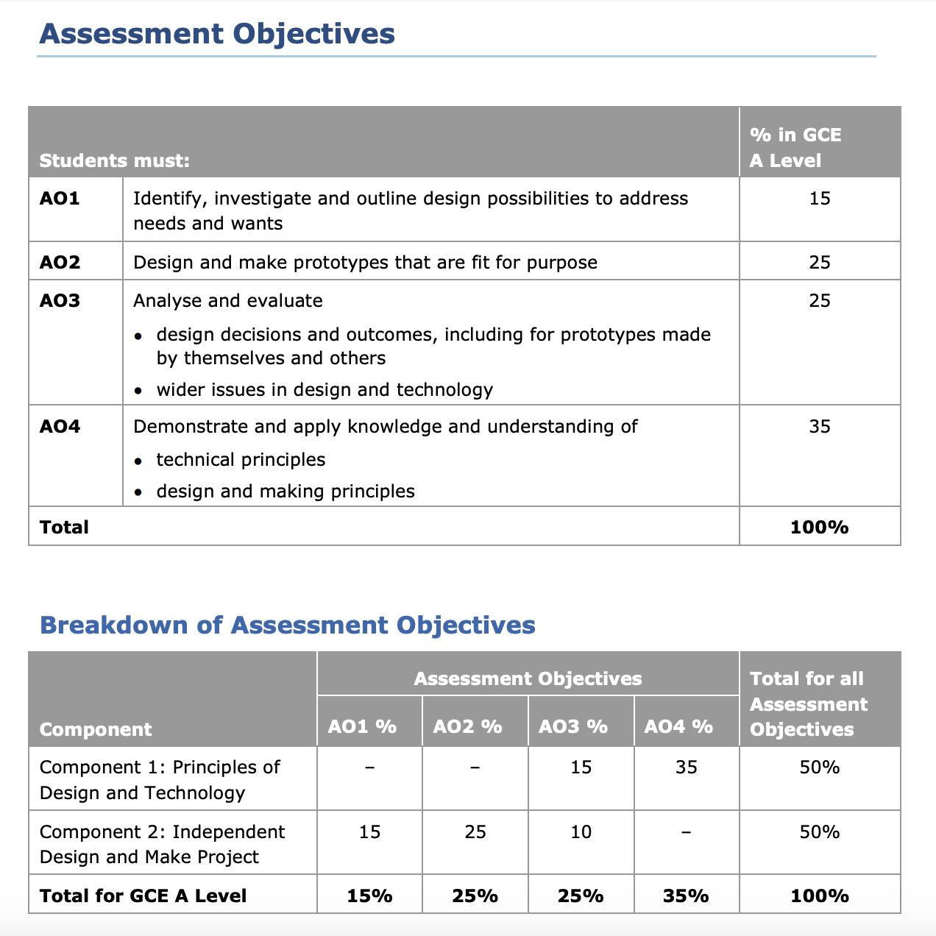
(50% exam and 50% coursework)

