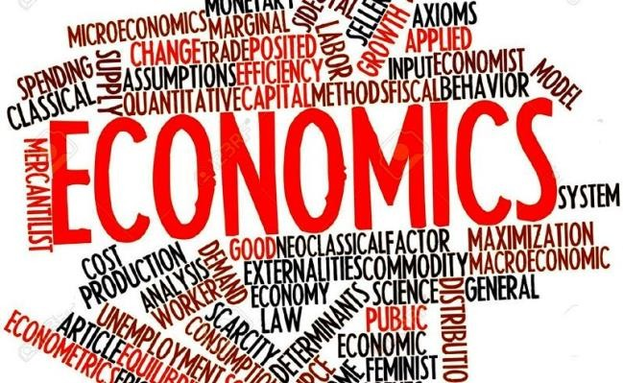
Year 11 Transition Work: Economics
Welcome to A Level Economics! I hope you are all safe and well.

You probably don’t know too much about Economics at this stage, however you will soon appreciate its importance to society and how we live our lives. The 2008/09 global recession, Eurozone crisis, BREXIT and COVID-19 means that there are always interesting articles appearing in the news related to Economics for you to follow. I hope you enjoy these introductory activities into the fascinating world of Economics and look forward to welcoming you onto the course in September. To prepare you for September, I would strongly encourage you to complete the tasks outlined below. How you chose to present your work is completely up-to-you, but be prepared to share what you find out with others in the group in September.
Ms Lee

Topic | Research Task
Introduction to Microeconomics | Starting with a definition of what Microeconomics is, complete your own research about the topics / issues that this might involve and how these are seen in our everyday life.  Often these issues involve contentious debate as people with different experiences and emotions are inclined to suggest different solutions, for example, how to solve the problem of obesity. Therefore, it is important to use data to justify our recommendations of how to solve these issues.  Research any ONE of the markets listed below, explain the relevance to Economics, outlining the  nature of the ‘problem’ and discuss various suggestions put forward to deal with it. Has the  government been successful in tackling these?

- Housing - is the UK in crisis?
- Processed and sugary food
- Teenage binge drinking
Economics of Oil | Oil is a key commodity for all economies and its price, supply and demand is often an indicator of how economies around the world are performing. Carry out research on the following:  - Current price of oil (quoted in price per barrel)  - The trend in the past 3 years (showing the price on a graph is the best way to show this)  - What is “OPEC”?  - Member countries  - Purpose of OPEC  - Recent developments – in the past 3 years  Why is the oil industry struggling?  Who are the key players in oil production? Why has there been a price war?  Are there any political issues to consider? What is the impact of the pandemic?  What is the most significant reason for crashing oil prices?
The impact of the Corona Virus on the UK economy - looking at the key economic indicators  a) Unemployment | All of the questions below will need completing. These will give you a basic understanding surrounding some of the topics you will cover in the Yr12 Macroeconomics course.  Use all the resources available to you.  The internet will have a HUGE amount of information, for you to answer these questions below. Make sure you answer all questions in detail! Have fun there is lots of interesting learning in here!  - Outline briefly a quick introduction/facts about COVID 19  Impact on the UK economy:  - What is the current rate of unemployment in the UK economy?  - Can you explain briefly how it is measured? Research and explain the labour force survey and the claimant count measures of unemployment.

- What will happen to the rate of unemployment in the next three months? Make a new prediction!
- What type of jobs will be lost because of the Coronavirus? Provide lots of details here. Which jobs might be more protected or safe? Give examples. Are there any firms that might be looking to recruit new workers in light of the crisis? Refer to jobs in the private sector and the public sector in this section. What will happen to the number of self-employed people?
b) Inflation | - What is the current rate of inflation in the UK economy? Can you explain briefly how inflation is measured/calculated in the UK economy?  - Explain the difference between the Consumer Price Index and the Retail Price Index?  - What will happen to the rate of inflation over the coming months? Give reasons for your answer! Will it go up or down?  - What might happen to the prices for certain goods/services in our economy? Provide examples!
c) Economic growth | - What is the current rate of economic growth in the UK? Explain what is meant by GDP? How is it measured? What will happen to economic growth in the next few months? Will it go up or go down? Explain your answer!  - Explain the difference between Nominal and Real GDP?  - Research what is meant by the economic cycle. Can you explain what is meant by a boom, slowdown, recession and a recovery? Do you think the UK economy is heading for a V or a U shaped recovery? Explain your answer if you can!  - Which areas of the economy will be hardest hit? Which businesses will suffer over the next few months? Which businesses might prosper? Give reasons for your answer.
d) Exchange rate | - What is the current exchange rate for the UK in relation to the euro and the US dollar? Will the pound get stronger or weaker? Give reasons why this might happen. Can you predict what rate the pound will be worth against the euro and dollar in September?  - Does a strong pound help UK exports? Explain your answer  - Does a weak pound make UK imports more expensive? Explain
Policies to reduce the impact of the | Research how the UK government has tried to reduce the impact of the Corona Virus on the

Corona Virus on the UK economy (1) | UK economy….  a) What has happened with the interest rate in the UK economy? What is the current base rate of interest? Can you explain why the Bank of England have lowered interest rates? How might this help consumers and businesses in our economy?  Produce a fact sheet on the Bank Of England.  (Brief History, Key functions of the Bank of England, How and why does it use interest rates to  manage the economy?)
Policies to reduce the impact of the Corona Virus on the UK economy (2) | Find out what other measures the Government have undertaken to help the economy and businesses.  b) Research four policies the Government have used to help workers and businesses. Can you provide a brief summary of these and write these up in a short paragraph for each policy? Can you research what other countries have done to help their economy and business? Choose two countries and explain three measures they have undertaken to help their economy and  businesses.

Please find below an excellent series of web links that will give you a real head start before you begin the course in September.

Each link will take you to informative power points, videos and articles for you to access.

Introduction to Macroeconomics

https://www.tutor2u.net/economics/reference/head-start-economics-introduction-to-macroeconomics

https://www.tutor2u.net/economics/reference/globalisation-head-start-to-a-level-economics

https://www.tutor2u.net/economics/reference/unemployment-head-start-in-a-level-economics

Economics of the Corona Virus Pandemic

https://www.tutor2u.net/economics/reference/economics-of-the-crisis-micro-and-macro-aspects-head-start-in-a-level-economics

https://www.tutor2u.net/economics/reference/economics-of-the-crisis-impact-on-businesses-head-start-in-a-level-economics

https://www.tutor2u.net/economics/reference/economics-of-the-crisis-policies-to-avoid-a-depression-head-start-in-a-level-economics

https://www.tutor2u.net/economics/reference/economics-of-the-crisis-inequalities-and-the-pandemic-head-start-in-a-level-economics.

