Year 12 Transition Pack

BTEC Level 3 National Extended Certificate in Health and Social Care

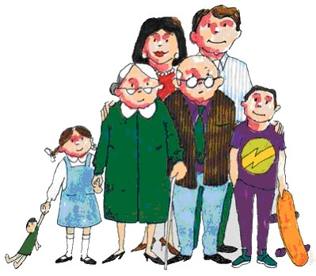

What is Health and Social Care?

Health services are the services in society which are designed to meet the health needs of the population. This includes hospitals, health centres, mental health support, and involves the work of professionals such as doctors, nurses, midwives and healthcare assistants.
Social care services provide support and care for individuals with additional needs. From care homes to social workers, all aspects of social care provide support for people going through difficult times in their lives when they have specific care needs which must be met.
All qualifications in health and social care are designed to prepare students with the knowledge and skills necessary to work in challenging job roles in both health services and the social care sector.
A BTEC Level 3 qualification in health and social care could prepare you for further training at university to pursue a career in professions such as social work, nursing or midwifery; or it could be used as preparation for applications to work as a health care or support assistant in a number of different care settings.

If you choose to study BTEC Level 3 Health and Social Care, you will be studying for an Extended Certificate in this subject which is worth the same amount of UCAS points as a traditional A level qualification.
The units you will study are:
Unit name |  | Key content | Assessment
1 | Human  Lifespan  Development | - Human growth and development  Through the life stages  - Factors affecting human growth and development  - Effects of ageing | You will be assessed by an EXAM, lasting 1 hour 30 minutes. It is worth 90 marks.  The exam includes short and long answer questions.
2 | Working in  Health and  Social care | - The roles and responsibilities of people who work in the health and social care sector  - The role of organisations in the health and social care sector  - Working with people with specific needs | You will be assessed by an EXAM, lasting 1 hour 30 minutes.  It is worth 80 marks.  The exam includes sections of different groups of service users
5 | Meeting  Individual  Care and  Support needs | - Principles, values and skills which underpin meeting care and support needs of individuals  - Ethical issues involved in providing care and support  - Enabling individuals to overcome challenges  - Investigating how professionals meet individual care and support needs | You will be assessed by a series of COURSEWORK ASSIGNMENTS.  These will be assessed in school, by your tutor.
11 | Psychological  Perspectives | - Examine how psychological perspectives contribute to the understanding of human development and behaviour Models and concepts of health and ill health  - Examine the contribution of psychological perspectives to the management and treatment of service users’ specific behaviours  - Examine how psychological perspectives are applied in health and social care settings. | You will be assessed by a series of COURSEWORK ASSIGNMENTS.  These will be assessed in school, by your tutor.
For more information and sample exam papers, please see the BTEC website:
http://qualifications.pearson.com/en/qualifications/btec-nationals/health-and-social-care-2016.html
BTEC Level 3 National Extended Certificate in Health and Social Care is Equivalent in size to one A Level. You will complete 4 units, two of these are external

This qualification will give you a broad basis of study for the health and social care sector and is designed to support progression to further study.

In year 12 the exam unit will be unit 1 - Human Lifespan Development which explores development from conception to old age, and the coursework unit will be unit 5 - Meeting Individual Care and Support Needs which looks at the care and support people need throughout their lives.

In year 13 the exam unit will be unit 2 – Working in Health and Social care which explores the job roles available in Health and social care and the roles and responsibilities of them, and the coursework unit will be Psychological Perspectives which explores the key theoretical perspectives that have been put forward on psychological and physical development and how they are applied in different health and social care settings.

Each unit gives you the opportunity to gain pass, merit or distinction grade and you will taught all areas to give you the best chance to achieve the best grade possible.

Preparation work

You will need to complete a preparation task before you start your Health & Social Care course in September. Completion of this preparation work is a pre-requisite to acceptance on this course. It must be handed in on your first Health & Social Care lesson in September.

TASK

Development and life events

For this task you need to choose one year/age from each age group below;

- 0-10 years
- 11-20 years
- 21-50 years
You then need to research that age and write about;
- the expected development for that age
- what life experiences (expected/unexpected) they might experience
- how these experiences might affect them and their development
You can include images if you wish to enhance your work.

Promoting Health and
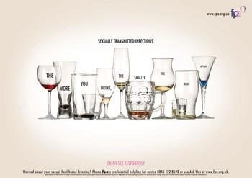
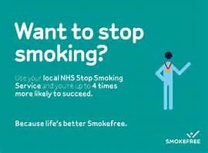
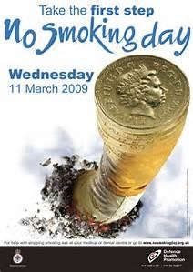
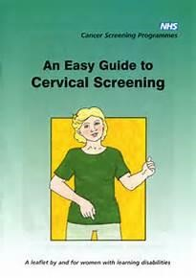
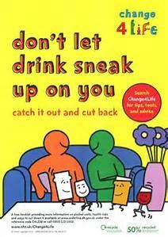
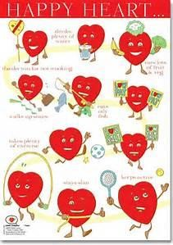
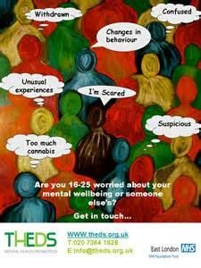
Wellbeing
Investigate how health risks can be addressed through health promotion
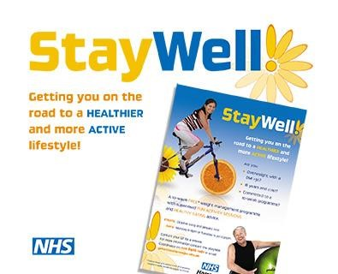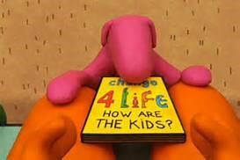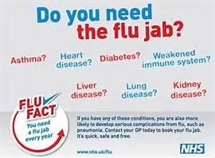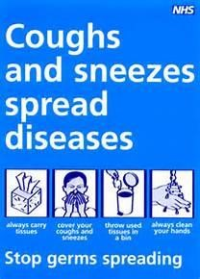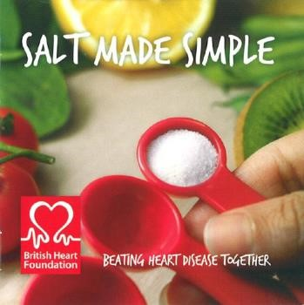

Scenario
You are volunteering at a community centre and your manager is aware that you are studying a Health and Social Care course.
The centre is organising a health promotion event. You have been asked to select one specific target group, choose a relevant health risk and prepare materials about these for the event.
You should research some information on your chosen health risk and use this information to produce materials for a health campaign.

Task 1: Research
Choose an age group and then decide on one of the following health risks to research: • Safe sex
- Healthy eating
- Hand washing
- Participation in sport
- Road safety
Prepare a written summary of your research. Remember to name your source and to write in your own words.

Task 2: Health Promotion to Target Groups
- Produce appropriate materials for the health-promotion activity, which should be tailored to the chosen target group. These materials could be in the form of a leaflet or a poster. The promotional materials must clearly describe the health risk and appropriate health advice.
- Explain, with reasons, how you would change the campaign to target a different age group.
- Evaluate the effect of following the promotion advise on the health and well-being of the individual (how will a person benefit from the promotion)

Task 3: Report
You need to write a report on the process of completing the health promotion. The report should include:
- Why you decided to choose the topic?
- What types of research did you use to gather information?
- How difficult was it to do the research?
- Was the research a benefit to you?
- What are the good points of your work?
- What do you think needs to be changed?

