Reading list and suggested online tutorials
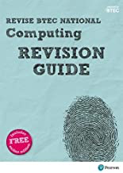 | Revise BTEC National Computing Revision Guide: (with free online edition) (REVISE BTEC Nationals in Computing)
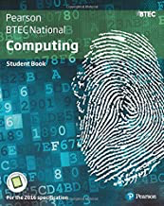 | BTEC National Computing Student Book (BTEC Nationals Computing 2016)
 | Intro to HTML/CSS: Making webpages
 | https://www.w3schools.com/python/
 | Past exam papers and mark schemes

